GAMMA RAY SPECTROMETRIC ANALYSIS AND ASSESSMENT OF RADIATION HAZARDS IN SOILS OF MBEERE NORTH REGION, EMBU COUNTY

JOYCE WAMBUI MUYA

A Thesis Submitted to the Graduate School of Physical Sciences, Engineering and Technology in Partial Fulfillment of the Requirements for the Award of Degree of Master of Science in Physics of Tharaka University

THARAKA UNIVERSITY
OCTOBER 2024

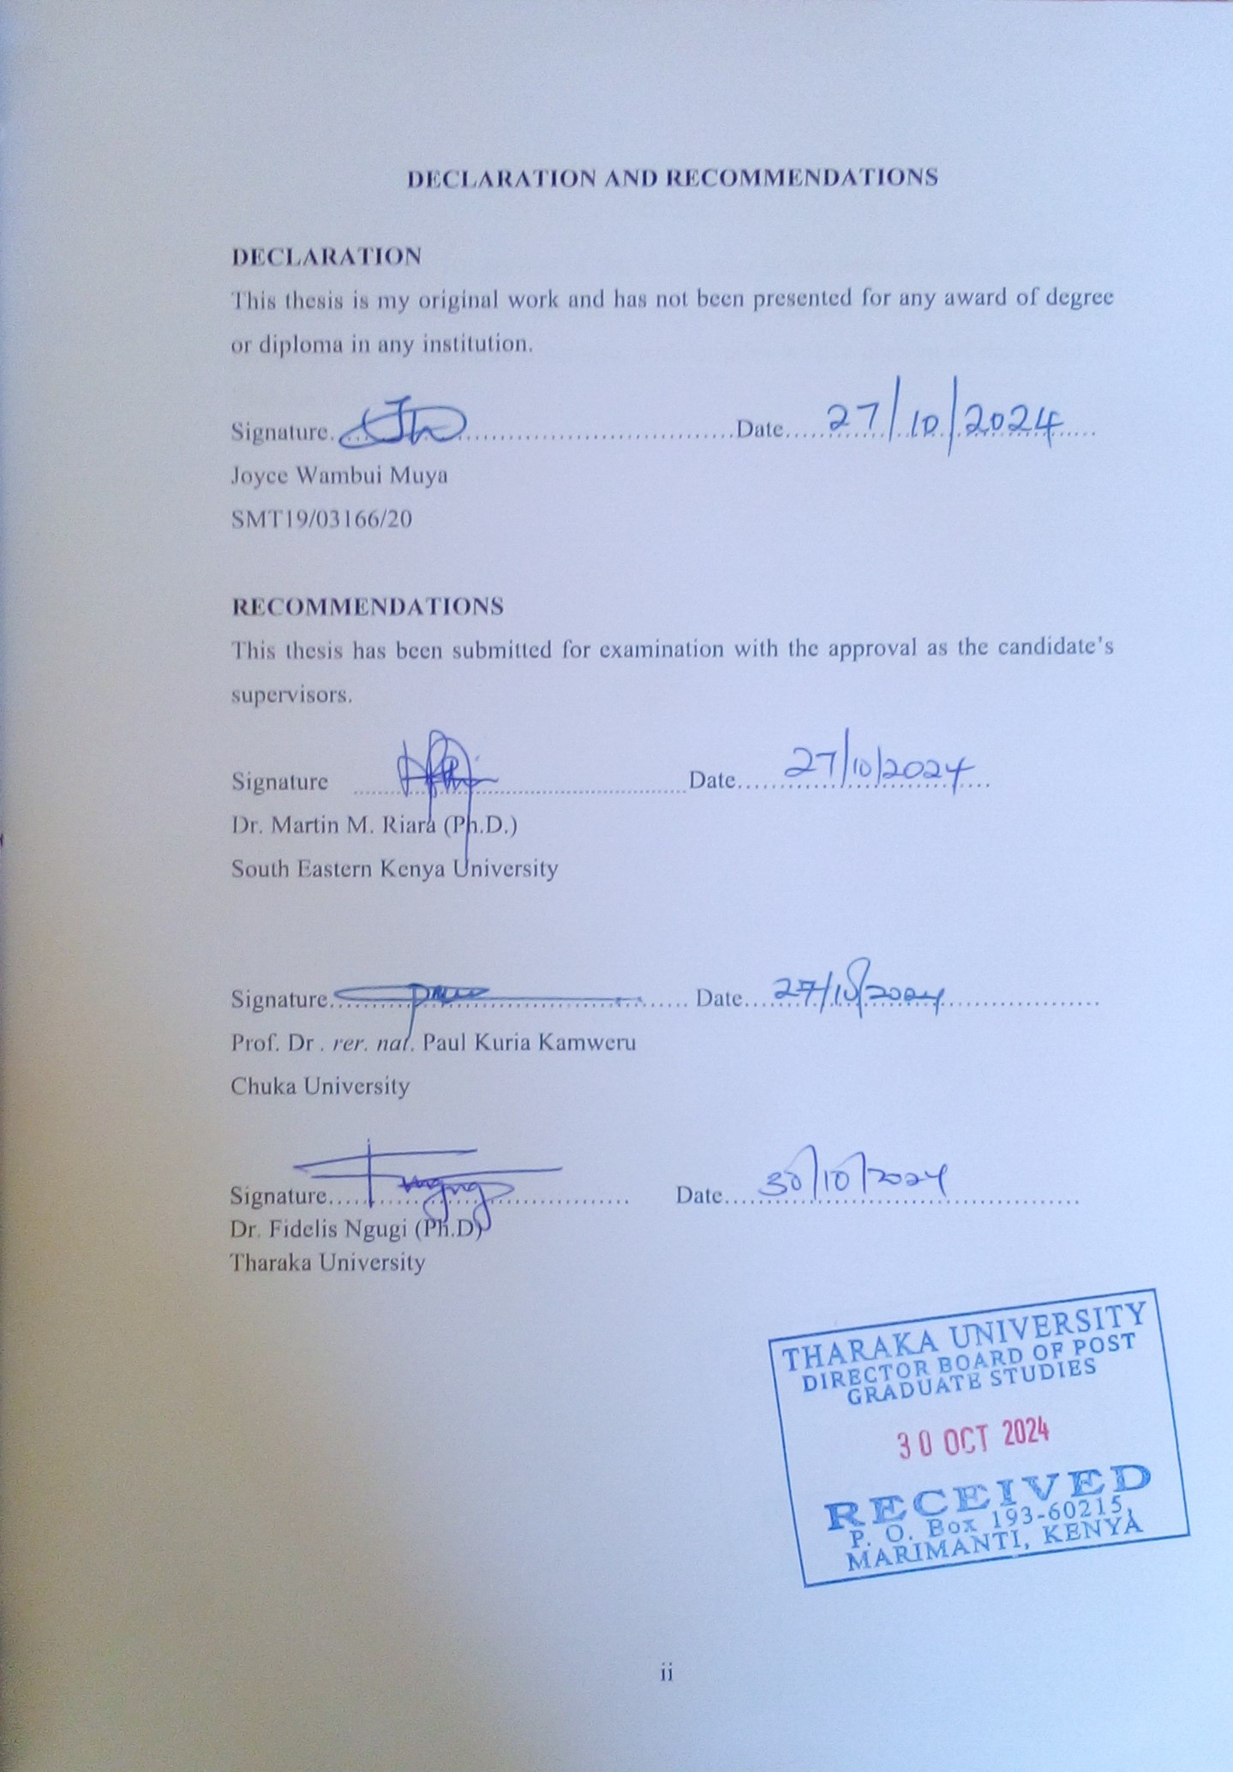

COPY RIGHT
©2024
All rights reserved. No portion of this thesis may be produced, stored in a retrieval system, or transcribed, in any form or by any means, electronic, mechanical, photocopying, recording or otherwise, without prior written consent of the author or Tharaka University.

DEDICATION
I dedicate this project to my daughters, Loise Kathomi Gitonga, a student at Pangani Girls in Nairobi, and Magdalene Nyambura Gitonga, who attends St. Peters Upper Primary School in Ishiara. May you always reach for the stars. I also dedicate this work to all those who pursue the study of physics.

ACKNOWLEDGEMENT
I would like to express my heartfelt gratitude to the Almighty God for the abundant grace and strength provided to complete this project. All honor and glory belong to You.

I extend my deepest appreciation to my supervisors: Dr. Martin M. Riara (Ph.D.) from South Eastern Kenya University (SEKU), Prof. Dr. rer. nat. Paul Kuria Kamweru from Chuka University, and Dr. Fidelis Ngugi (Ph.D.) from Tharaka University. Your unwavering guidance has been instrumental in the success of this research. May God bless you abundantly.

I also want to thank my lecturers for their support, and I am especially grateful to my parents, Stanley Muya and Margaret Nyambura, for instilling in me a love for education. My appreciation extends to my daughters, Loise Kathomi and Magdalene Nyambura, as well as my siblings (Grace Muya, Mary Muya, Jane Muya and Edward Muya), and all my relatives. My father-in-law, Delfino Ngece thanks a lot. I would like to express my gratitude to Dr. James Ndwiga from Tharaka University; your assistance made the sample collection process an enjoyable adventure.

Special thanks to my friends and everyone who contributed to the successful completion of this project. I also wish to acknowledge the laboratory staff at both Tharaka University and SEKU for their support during my research. Lastly, I would like to express my sincere appreciation to Tharaka University for providing the research funding.

ABSTRACT
Both immediate and long-term health problems can result from exposure to high and moderate intensity radiation. This study looked into the amounts of naturally occurring radioisotopes that produce gamma rays in soil samples that were taken from several sites in Embu County's Mbeere North area. Although the native society in central-eastern Kenya relies heavily on this region for construction bricks, the radiation safety of this raw material has not yet been evaluated. Furthermore, there has been a significant increase in cancer incidence in Embu County and the surrounding areas, albeit the exact cause remains unknown. Fifty soil samples weighing roughly 1000 g each were collected at a deepness of roughly 10 cm from various positions in the Mbeere North region. From each location, three samples weighing around 350 g were collected from a 1 m by 1 m area, which were then combined to create a single representative sample. The inter-sampling distance varied between sites but was kept within 4 to 5 km. Special attention was given to areas involved in brick making. In cases where brick-making sites were distant, samples were collected from areas with other anthropogenic activities, such as quarrying, sand harvesting, and farming of crops like Catha edulis (khat), cowpeas, sunflowers, and green grams. Each sampling site's coordinates were recorded using global positioning system (GPS) technology. Using a sodium iodide activated with thallium (NaI(Tl)) gamma-ray spectrometer, the radioactive decomposing rates of ²³²Th, ²³⁸U, and ⁴⁰K in the soil samples were determined. ²³²Th, ²³⁸U, and ⁴⁰K were pinpointed to have mean activity absorptions of 149.74±2.82 Bqkg⁻¹, 88.34±2.39 Bqkg⁻¹, and 490.35±35.24 Bqkg⁻¹, respectively. These concentrations were higher than the global median of 45, 33, and 420 Bqkg⁻¹ for these radionuclides. It was discovered that these radionuclides had an uneven spatial distribution throughout the area.157.93±4.40 nGyh⁻¹, 0.58±0.02 mSvy⁻¹, and 0.39±0.01 mSvy⁻¹ were the mean absorbed dosage, and innermost and outmost yearly effective dose rates, following that order. The absorbed dosages in around 0.96 of the cases were greater than the 57 nGyh⁻¹ global mean. Despite this, all values were beneath the 1500 nGyh⁻¹ suggested safe end. Effective dose rates indoors were below the permissible level of 1 mSvy⁻¹ in about 0.94 of the samples, and all outdoor yearly effective dose rates were unbefitting this limit as well. Internal hazard indicator, exterior risk index, and radium equivalent had mean values of 1.14±0.03, 0.92±0.02, and 340.70±9.20 Bqkg⁻¹, singly. The mean internal hazard indicator was the sole radiation safety needle that was marginally above the safe gauge. Therefore, it is deemed safe to utilize the soils from Embu County's Mbeere North region for brick-molding and fabrication.

TABLE OF CONTENTS
DECLARATION AND RECOMMENDATIONS ii
COPY RIGHT iii
DEDICATION iv
ABSTRACT vi
TABLE OF CONTENTS vii
LIST OF TABLES x
LIST OF FIGURES xi
LIST OF ABBREVIATIONS, ACRONYMS AND SYMBOLS xii

CHAPTER ONE: INTRODUCTION 1
1.1 Background to the Study 1
1.2 Statement of the Problem 6
1.3 Objectives 6
1.3.1 Specific Objectives 6
1.4 Research Questions 7
1.5 Justification of the Study 7

CHAPTER TWO: LITERATURE REVIEW 9
2.1 Introduction 9
2.1.1 Global Studies on Natural Radiations 9
2.1.2 Radiation Studies in Africa 12
2.1.3 Radiation Surveys in Kenya 15
2.2 Theoretical Foundation 18
2.2.1 Radioactivity Decay 18
2.2.2 Types of Radiations 20
2.2.3 Gamma Decay 21
2.3 Interaction of Gamma Rays with Matter 21
2.3.1 Photoelectric Effect 21
2.3.2 Compton Scattering 22
2.3.3 Pair Production 23
2.4 Transmission of Gamma Rays through Matter 24
2.5 Uranium-232 Decay 24
2.6 Thorium-232 Decay 25
2.8 Gamma-Ray Spectrometry 26
2.8.1 NaI(Tl) Gamma-Ray Spectrometer 26
2.8.2 The Gamma-ray Spectrometer's Specifications 27
2.8.3 Working Mechanism of NaI (Tl) Detector 27

CHAPTER THREE: METHODOLOGY 29
3.1 Study Area. 29
3.2 Materials and Equipment used. 30
3.3. Sampling, Sample Gathering, and Sample Preparedness 31
3.4 Requirement Prior to Sample Counting 32
3.4.1 NaI (TI) Detector Energy Fine-Tuning 32
3.4.2 Detector Counting Resolution and Efficiency 33
3.4.3 Background Correction 34
3.5 Radiometric Variables 34
3.5.1 Activity Concentration 35
3.5.2 Absorbed Dose (AD) 35
3.5.3 Annual Effective Dose (AED) 35
3.5.4 Radium Equivalent (Ra_{eq}) 36
3.5.5 Internal Hazard Index (H_{in}) 37
3.5.6 External Hazard Index (Hex) 37
3.6 Ethical Considerations 38

CHAPTER FOUR: RESULTS AND DISCUSSIONS 39
4.1 Activity Absorptions of ²³²Th, ²³⁸U and ⁴⁰K 39
4.2 Absorbed Dose and Annual Effective Dose Rates 46
4.3 Radium Equivalent, Internal and External Hazard Indices 51

CHAPTER FIVE: SUMMARY, CONCLUSION AND RECOMMENDATIONS 57
5.1 Summary 57
5.2 Conclusions 58
5.3 Recommendations 58

REFERENCES 59
APPENDIX I: CHARTS 71
APPENDIX II: INTRODUCTORY LETTER 76
APPENDIX III: ETHICS CLEARANCE 77
APPENDIX IV: RESEARCH PERMIT 78

LIST OF TABLES
Table 4.1 : Activity concentration ²³²Th, ²³⁸U and ⁴⁰K 39
Table 4.2: Linkage of activities in Soil in this probe with parallel studies. 45
Table 4.3 :Absorbed dose and annual effective dose rates. 47
Table 4.4: Radium equivalent, internal and external hazard indices 51

LIST OF FIGURES
Figure 1.1: Contribution of varied radiation origins expressed as a percentage 1
Figure 1. 2: Cancer prevalences per county 4

Figure 2.1: Summary of the three types of radiations. 20
Figure 2.2: Movement and absorption power of alpha beta and gamma radiations. 21
Figure 2.3: Photoelectric effect 22
Figure 2.4: Compton effect. 23
Figure 2.5: Pair production. 24
Figure 2.6: Uranium radioactive series 25
Figure 2.7: Thorium radioactive sequence 26
Figure 2.8; Schematic diagram of NaI (TI) gamma-ray spectrometer. 27
Figure 2.9; Schematic of NaI(Tl) scintillation detector . 28

Figure 3.1: Topographic Map of Embu County showing Mbeere North Subcounty showing sampling points. 29
Figure 3.2; Results of energy calibration 33

Figure 4.1 Activity concentration of ²³²Th in the dirt samples 41
Figure 4.2: Activity concentration of ²³⁸U in soil samples. 42
Figure 4.3: Activity concentration of ⁴⁰K in the samples 43
Figure 4.4: Absorbed dose rate of the assembled samples. 48
Figure 4.5: Indoor annual equivalent dose rate of the gathered samples. 49
Figure 4.6: Outdoor yearly equivalent dose rate of the collected samples. 50
Figure 4.7: Radium equivalent of the collected samples. 53
Figure 4.8: External hazard index of the collected samples. 54
Figure 4.9: Internal hazard index of the collected samples. 55

LIST OF ABBREVIATIONS, ACRONYMS AND SYMBOLS
AD | Absorbed Dose
AED | Annual Effective Dose
AEZ | Agro Ecological Zone
AEDR | Association for Environment and Development Research
ADC | Analogue Digital Converter
ADR | Annual Dose Rate
ARS | Acute Radiation Syndrome
BDL | Below Detectable Level
BqKg⁻¹ | Becquerel per Kilogram
CAN | Calcium Ammonium Nitrate
CRI | Cutaneous Radiation Injuries
DNA | Deoxyribonucleic Acid
FWHM | Full Width at Half Maximum
EPA | Environmental Protection Agency
GoK | Government of Kenya
GPS | Global Positioning System
HBRA | High Background Radiation Area
IAEA | International Atomic Energy Agency
H_{in} | Internal Hazard Index
Hex | External Hazard Index
ICRP | International Commission on Radiation Protection
KNRA | Kenya Nuclear Regulatory Authority
KRPB | Kenya Radiation Protection Board
MCPA | Multichannel Pulse Analyzer
MCS | Monte Carlo simulation
mSvy ⁻¹ | milli severt per year
NACOSTI | National Commission for Science, Technology and Innovation
NaI(Tl) | Sodium Iodide Activated with Thallium
NEMA | National Environment Management Agency
NCI | National Cancer Institute
NCRP | National Commission on Radiation Protection
nGyh ⁻¹ | nano Gray per hour
NORM | Naturally Occurring Radioactive Material
NPK | Nitrogen Phosphorus and Potassium
PC | Personal Computer
RAI | Radiation Alert Detector
UNSCEAR | United Nation Scientific Committee on Effects of Atomic Radiations.
WHO | World Health Organization

CHAPTER ONE: INTRODUCTION

1.1 Background to the Study
Radioactivity is the spontaneous decay of an unstable atomic nucleus, leading to the production of daughter nuclides and often the emission of gamma-ray photons (Vallabhajosula et al., 2023). These photons possess enough energy to ionize molecules by removing electrons. Radiation springs from both spontaneous and semisynthetic origins (UNSCEAR, 2008). On average, around 81% of an individual's yearly background radiation predisposition is attributed to fountains such as astronomical and earthbound radiation (Al-Khawlany et al., 2018). The remaining 19% mainly comes from human-made commencements, including curative procedures like X-rays, nuclear diagnostics, along with certain end user products (Khabana et al., 2020). Figure 1.1 depicts the donations from different radiation springs expressed as a percentage (WHO, 2016)
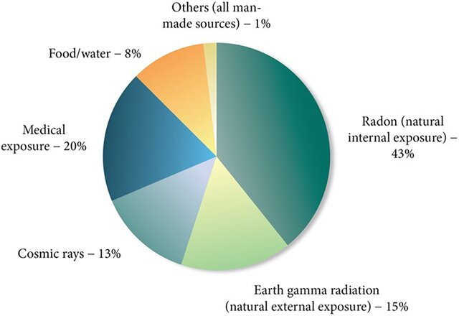
Figure 1.1: contribution of varied radiation origins expressed as a percentage (WHO, 2016)

The majority of human vulnerability to ionizing radiation comes from beginnings that occur spontaneously (Charles et al., 2001). Such radiations originate either from cosmic rays outside the Earth or from terrestrial radionuclides that occur naturally (Orgun et al., 2007). The concentration of terrestrial radioisotope, which degenerate and release ionizing radiation, can be elevated by natural events such as erosion and volcanic activity, as well as by hominid activities like hollowing and horticulture (Mutunga et al., 2018). Regions with substantial levels of primordial radioactive elements, such as ⁴⁰K, ²³²Th, ²³⁸U (Shaheen et al., 2023), which are classified as high background radiation areas (HBRAs). Inhabitants in some areas, such as Ramsar, Iran, are exposed to significantly elevated radiation levels, reaching up to 260 mSv per year, primarily due to radium-226 found in local hot springs (Achola et al., 2010). Several HBRAs have been identified here in Kenya, including Mrima Hill (Chege et al., 2014), Lambwe East in southwestern Kenya (Achola et al., 2010), and areas located the way of the Lake Victoria shoreline in Migori County (Daniel et al., 2015). The elevated radioactivity in these regions is attributed to the proximity of large mass of uranium together with thorium in carbonatite rocks (Achola et al., 2009).

The lithosphere house varying amounts of primordial radioisotopes, namely ⁴⁰K, ²²⁶Ra, and ²³⁸U (Shaheen et al., 2023), particularly via rocks and dirt (UNSCEAR, 2000). These radionuclides can enter homes through building materials derived from granitic and gneiss rocks or from sediments weathered from these rocks. A significant source of radiation exposure in households, both internally and externally, comes from naturally occurring radionuclides present in construction materials (Laniyan et al., 2021). According to Tufail et al., (2007), indoors, radiation exposure from alpha, electron, and gamma particles —primarily via radon and her decay products—is generally lower than external gamma radiation (Tufail et al., 2007). Internal exposure may also occur through the ingestion of radioactive substances in food and water or by inhaling airborne radioactive particles (Khabana et al., 2020). Since people spend around 60% of their time indoors, it is meaningful to appraise radioactivity levels in artefacts (Sonkawade et al., 2008), to identify potential radiological risks to human health (Chege et al., 2015).

The tolerable average activity concentrations in our environment are 420 Bqkg⁻¹ for ⁴⁰K ,33 Bqkg⁻¹ for ²³⁸U, and 45 Bqkg⁻¹ for ²³²Th. Exposure to higher levels of radiation can negatively impact health (UNSCEAR, 2017). The Intercontinental Commission on Radiological Patronage (ICRP, 2016) admonish the general population not by any means be exposed to more than 1 mSv per year of radiation, warning that doses above this limit may lead to biological effects. These effects are classified as either stochastic or non-stochastic. Stochastic effects, such as radiation-induced cancer and genetic mutations, occur by chance and their severity does not depend on the dose. Non-stochastic effects, on the other hand, are dose-dependent and include conditions such as reduced sperm count, changes in blood composition, lens opacification, and fibrosis. Radiation exposure can also weaken the immune system (UNSCEAR, 2008).

High levels of radiation exposure can lead to both immediate and long-term health effects. Openness to minor radiation for a very long duration of time has been associated with congenital changes (Killewich et al., 2011)., which may result in conditions such as developmental delays, cancer, benign tumors, and cardiovascular diseases, among other chronic health issues (UNSCEAR, 2000). In contrast, short-term exposure to high radiation levels primarily causes acute health effects. Daniel et al., (2015) gives examples of these effects inclusive of skin reddening, baldpatedness, combusts resulting from radiation, and acute radiation syndrome (ARS), commonly referred to as "radiation sickness." ARS is a serious condition that arises from whole-body exposure to increased radiation dosage from natural sources. High-energy radiation poses a health peril as it can damage tissues and alter the DNA within cells, potentially leading to further health complications. Additionally, cutaneous radiation injuries (CRI) may occur as a result of high radiation exposure.

A study conducted by the National Cancer Institute (NCI) to evaluate cancer prevalence in Kenya found the highest rates of esophageal and prostate cancers in Nairobi, Kisumu, Meru, Mombasa, Kakamega, Nakuru, Bomet, Nyeri, and Embu counties (Cronin et al., 2018), as illustrated in Figure 1.2. In Meru County, cancer prevalence was evenly distributed between genders, with notably high rates of stomach and esophageal cancers (Kobia et al., 2019). The researchers suggested that the consumption of hot tea in conjunction with chewing miraa (khat) might contribute to the development of these cancers.

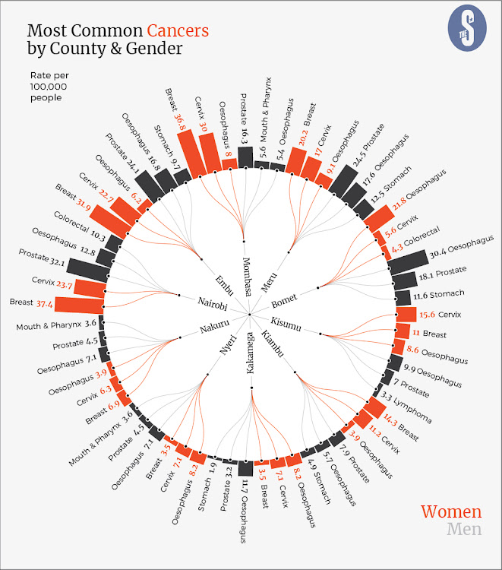
Figure 1. 2: Cancer prevalences per county (Cronin et al., 2018)

In rural Kenya, soil plays a significant role in the building industry, as most houses are constructed using mud or bricks made from soil or sand. Conducting a study on natural radioactivity is essential for identifying potential radiation hazards in residential areas. The geology of a region influences the concentrations of radioisotopes ²³⁸U, ²³²Th, and ⁴⁰K, of the kind that determine overall radiation menace faced by that area (Shaheen et al., 2023). In Embu County, the Mbeere North region is recognized for its substantial deposits of iron ore, gemstones, graphite, magnesite, and pegmatites. Brick making is a prevalent economic activity in this region, serving both the local market and neighboring counties such as Tharaka Nithi, Machakos, and Kirinyaga. The bricks produced here are noted for their high quality, and the sand from this area is regarded as among the best for construction in the entire country (Waweru et al., 2020).
Embu County features two main types of housing: permanent and semi-permanent. According to the 2009 census, 121,230 households in Embu County utilize corrugated iron sheets. Among the permanent homes, 54,114 are constructed with materials such as corrugated iron sheets, tiles, and shingles supported by timber trusses for roofing. Walls of these permanent dwellings are typically made of bricks, hand-manufactured concrete blocks, or quarry stones. Such homes are prevalent in Embu Town as well as the rural areas of Embu East subcounty, Embu West subcounty together with Embu North Sub County, with multi-story permanent houses dominating Embu Town. Additionally, 4,690 households in Embu County rely on tin, makuti, or grass for roofing. The walls of these homes may be constructed from stabilized interlocking earth bricks, mud, wood, or a combination of these materials. Depending on the level of stabilization, interlocking earth bricks can also be used to build permanent homes. Most semi-permanent dwellings are located in Mbeere North and Mbeere South Sub Counties.
Given the high incidence of various types of cancer reported in Embu County, it is crucial to conduct comprehensive research on the natural radioactivity of the region's soil. This study involved analyzing soil samples from specific regions in Mbeere North using Gamma Ray Spectrometer to quantify the amounts of primordial radioactive elements contained by the soil. The area comprises clay and sandy soils containing granitic deposits resulting from the weathering of nearby rocks, including the Kirigo, Kamarandi, and Kiang'ombe hills. Additionally, the geological diversity in this region is notable. Therefore, the elemental intention for this study has been to assess the natural radiation levels associated with the soils in the Mbeere North region of Embu County and to evaluate the potential impacts of these altitudes of radiation on the community.

1.2 Statement of the Problem
Soil is the primary material used in construction in the Mbeere North region, where most houses are built with mud and bricks due to its availability and low cost. Additionally, local residents participate in brick-making to meet the demand in the wider Middle Eastern Kenya region. Despite the prevalent use of soil in construction, there is limited knowledge about its safety concerning radiation exposure. Moreover, Embu County and its neighboring areas have reported a significant number of cancer cases, with unknown causes or risk factors. Research indicates that soil can naturally contain radionuclides that have weathered from rocks originating from the lithosphere. Although many studies already documented the presence of naturally occurring radioactivity in Kenyan soils, there is currently no recorded data on radiation levels specifically in the Mbeere North region of Embu County.
This study aims to evaluate the radiation risks and engrossments of radioisotopes that occur spontaneously in the soils within Mbeere North. The findings will help assess the potential radiation hazards faced by residents living in homes constructed from soil or bricks sourced from this area. Additionally, the results will be vital for government bodies, non-governmental organizations, and scientific committees such as the United Nations Scientific Committee on the Effects of Atomic Radiation (UNSCEAR), the Kenya Nuclear Regulatory Authority (KNRA) and Environmental Protection Agency (EPA) also known as environmental impact assessment (EIA), with reference to the safeness of using local soil for construction purposes

1.3 Objectives
The greatest purpose of this research was to quantify soil radiation risks closed in Mbeere North region of Embu County through gamma-ray spectrometry

1.3.1 Specific Objectives
i. To quantify the accumulation of radionuclides (²³⁸U, ²³²Th, and ⁴⁰K) in soil samples collected from Mbeere North region of Embu County.
ii. To compute the radiation dose rates (both absorbed and annual effective) based on the concentrations of radionuclides found in the soil samples.
iii. To work out the internal, external, as well as radium equivalent radiological hazard indices for the soil samples

1.4 Research Questions
i. What are the preoccupations associated with the radioisotopes ²³⁸U, ²³²Th, and ⁴⁰K, are present in soil samples gathered from Mbeere North region of Embu County?
ii. What are the radiation absorbed and yearly effective dose rates derived amongst the concentrations of radionuclides associated with the soil samples?
iii. What are the external and internal radiological hazard indices, radium equivalent, and other related parameters for the soil tests?

1.5 Justification of the Study
In the Mbeere North region of Embu County, artisanal mining of soil, sand, and ballast is a key economic activity. This soil is utilized for various purposes, including brickmaking, agriculture, animal husbandry, and the construction of semi-permanent homes. The produced bricks are sold not only in the local market but also to neighboring counties such as Kirinyaga, Tharaka Nithi, and Machakos. It is widely acknowledged that natural radioactivity in soils can result from the vicinity of radionuclides (²³⁸U, ²³²Th, and ⁴⁰K) appearing in calcareous slag, gneisses, and schist within the Earth's crust (Karthikayini et al., 2024). Exposure to such radiation can have harmful health effects, including cancer (Qureshi et al., 2014). Embu County has been identified as one of the regions experiencing a rise in cancer cases (Kobia et al., 2019). Given that the Mbeere North region is a significant supplier of construction materials for the area and the county, the closeness of primordial radionuclides in the materials has become a matter of public concern.
Soil employment as a tool for building purposes is often favored due to its affordability, availability, and acceptable quality (Aslam et al., 2012). Construction soil is typically extracted from the Earth's surface, comprising a significant percentage of sediments deposited as a result of erosion and local mining activities. These sediments may contain naturally occurring radionuclides, which can expose occupants of homes built with such materials to natural radiation. The soils in this region include strongly weathered upland soils, hilltop soils on elevated areas, and dissected erosion plains along river bends. Furthermore, the increased use of fertilizers derived from phosphate rock, which is rich in ²³⁸U, ²³²Th, and ⁴⁰K, such as NPK, CAN, and Mavuno, may further elevate natural radiation levels in the Mbeere North region.
In research to critique the sum totals of natural radiation in the building sand of Tharaka Nithi County, adjacent to the Mbeere North region, the mean activity concentrations were figured to be 98 Bqkg⁻¹ for ²³⁸U, 1069 Bqkg⁻¹ for ⁴⁰K, while for ²³²Th was 53 Bqkg⁻¹ (Kamunde et al., 2016). The global average activity engrossments for these radionuclides in the environment are reported to be 420 Bqkg⁻¹ as for ⁴⁰K, 33 Bqkg⁻¹ as for ²³⁸U, and 45 Bqkg⁻¹ as for ²³²Th (UNSCEAR, 2017). Given that the same geological belt is present in the Mbeere North area, it is plausible that the sand in this region may also exhibit elevated mean concentrations. An investigation handled by Munyao et al. (2020) aimed at evaluating the radiation levels of gravel samples assembled from the Ekalakala River in Machakos County, which is in proximity of the Mbeere North region, found out that the mean activity absorptions of ²³⁸U, ²³²Th, and ⁴⁰K to be 14.3 ± 3.8, 17.3 ± 4.2 and 14.3 ± 3.8 all in Bqkg⁻¹ and following that order. These mean concentration contents were fell short of globally recommended thresholds.
Gamma-ray spectrometric technique was used to analyze the radiation levels from radionuclides present in dirt samples taken within the territories of the Mbeere North region of Embu County. The results thereafter, will avail important information about the potential risks acquired from radiation vulnerability connected to these primordial radionuclides in the soils of this area. Furthermore, the study will be significant for scientific organizations such as UNSCEAR and the EPA, as well as government and non-governmental agencies, in relation to the safety of using soil for construction purposes in the Mbeere North area

CHAPTER TWO: LITERATURE REVIEW

2.1 Introduction
Countless studies exist aa over the universe to rate the radiation risks as well as the contamination levels associated with sand, bricks, and soil utilized in construction. The average activity absorptions in the global for ⁴⁰K, ²³⁸U, and ²³²Th inside the range of the environment are reported as 420 Bqkg⁻¹, 33 Bqkg⁻¹, and 45 Bqkg⁻¹, in the order given (UNSCEAR, 2016). While both the rate of the amount of radiation energy absorbed per unit mass (absorbed dose rate) and the effective dose rate per annum are set at 1 mSvy⁻¹, the estimated value with respect to radium equivalent activity is marked down as 89 Bqkg⁻¹. Below is a summary of selected research related to this topic

2.1.1 Global Studies on Natural Radiations
Alzubaidi et al., (2016) employed a PC-based MCPA along with a high-purity germanium (HPGe) gamma-ray pointer to examine levels of radiation in both virgin and agricultural soils in Kedah, Malaysia. The study found an estimate value of activity concentrations for ⁴⁰K, ²³²Th, and ²²⁶Ra in agricultural soil as 325.87 Bqkg⁻¹, 133.96 Bqkg⁻¹, and 102.08 Bqkg⁻¹, in the order given. In contrast, the mean activity concentration values for ²²⁶Ra, ²³²Th, and ⁴⁰K in virgin soil were recorded at 65.24, 83.39, and 136.98 respectively all in Bqkg⁻¹. The calculated mean values for radium equivalent activity, absorbed dosage rate, the effective dose rate per year, and exterior hazard indicator (Nkoulou et al., 2018), for agricultural soils were 458.8 Bqkg⁻¹, 141.62 nGyh⁻¹, and 0.169 mSvy⁻¹, while those for virgin soils were 241.3 Bqkg⁻¹, 87.47 nGyh⁻¹, and 0.106 mSvy⁻¹. The results indicated that the mean value of concentration of ²³²Th exceeded that of the globe of 33 Bqkg⁻¹. However, no concentrations were found that posed a significant risk to human habitation
Senthilkumar et al., (2011) utilized gamma-ray spectrometry to analyze soil samples from the Thanjavur region in Tamil Nadu, India. Their findings indicated mean activity concentrations for ⁴⁰K, ²³⁸U, and ²³²Th (Solomon et al., 2018) of 149.5 Bqkg⁻¹, 14.7 Bqkg⁻¹, and 42.9 Bqkg⁻¹, separately. In a related study researched in Babylon City, Iraq, Karim et al., (2016) announced concentrations of ⁴⁰K, ²³⁸U, and ²³²Th (Rahman et al., 2007) as 170 Bqkg⁻¹, 15 Bqkg⁻¹, and 15.5 Bqkg⁻¹, respectively. These levels were confined in the acceptable reach suggested by the non-governmental World Health Organization. However, the average external dose rate from gamma rays in Kerala, India, was approximately 4.5 mGyh⁻¹, with an effective internal prescription of 2.4 mSv per year, ascribed to the area's phosphate and igneous rock types (Karim et al., 2016).
Additionally, a study by Rahman et al., (2007) utilized a gamma-ray detector with a p-type coaxial high-purity germanium to find out hazardous radiation from radionuclides of natural origin contained in soil samples from northwestern Pakistan. The mean activity concentrations of ²²⁶Ra, ²³²Th, and ⁴⁰K (Okedeyi et al., 2024) came out as 26 Bqkg⁻¹, 39 Bqkg⁻¹, and 485 Bqkg⁻¹, respectively, with external and internal hazard pointers revealed at 0.33 mSvy⁻¹ and 0.40 mSvy⁻¹ (Jibiri et al., 2009). The average effective dose from gamma rays was measured at 0.34 ± 0.12 mSvy⁻¹, with the concentration of ⁴⁰K exceeding global recommendations. A related study by Fatima et al., (2007) on natural radioactivity and dose rates in the soils of southern Punjab, Pakistan, indicated an estimate radium equivalent activity of 96.7 Bqkg⁻¹, with the rate of absorbed dose being 46.1 nGyh⁻¹ (Al-Zahrani et al., 2017). The findings suggested that the effective doses, hazard indices, and levels of natural radioactivity were within recommended limits, indicating unimportant risk to the local population (Kaliprasad et al., 2017), from the soil.
The levels of radiological perils affiliated with radionuclides of origin nature were assessed in fifteen soil samples taken out of Bangi Complex of the Malaysian Nuclear Agency (Mei-Wo et al., 2019), employing a high-purity germanium (HPGe) gamma-ray detector (Özden et al., 2021). The study revealed that the activity concentration of ²²⁶Ra in the soil specimens ranged in between 15.6 Bqkg⁻¹ and 60.3 Bqkg⁻¹. For ²³⁸U and ²³²Th, the activity concentrations were found to vary between 17.2 Bqkg⁻¹ and 85.4 Bqkg⁻¹, and within 23.9 Bqkg⁻¹ and 89.9 Bqkg⁻¹, for each. The absorption of ⁴⁰K in the samples ranged within 98.4 Bqkg⁻¹ and 499.4 Bqkg⁻¹. Higher activity concentrations were linked to soil types likely enriched with phosphate, quartzite, sandstone, and granite (UNSCEAR, 2000). The radium equivalent activity fluctuated in between 63.2 Bqkg⁻¹ and 217.9 Bqkg⁻¹, with an estimate of 105.6 Bqkg⁻¹ (Malik et al., 2011). The external radiation hazard ranged from 0.17 to 0.60 (Shrestha et al., 2024). Additionally, the overall outdoor dose rate fluctuated between 29.4 nGyh⁻¹ and 99.9 nGyh⁻¹, with estimate value of 49.1 nGyh⁻¹. Since these outcomes are short of the accepted ceiling in the universe, the soil was deemed safe for human use.
A study was conducted in the Bolu province of northwest Turkey to assess the radioactivity levels in soil samples (Dizman et al., 2019). Using gamma spectrometry in conjunction with a high-purity germanium detector, both manmade and spontaneous radionuclides (²²⁶Ra, ²³²Th, and ⁴⁰K) activity concentrations were analyzed (Cevik et al., 2009) in soil samples scooped at forty different sites in the Bolu region. The average activity concentrations recorded were as follows: ²²⁶Ra at 18.2 Bqkg⁻¹ with variance from 3.8 to 49.9 Bqkg⁻¹, ²³²Th at 17.3 Bqkg⁻¹ (varying between 4.1 and 37.9 Bqkg⁻¹), and ⁴⁰K at 258.3 Bqkg⁻¹ -ranging from 64.6 to 518.9 Bqkg⁻¹ (Al-Jundi et al., 2009). These radiation levels did not meet the global mean. The numerated radium equivalent activity (Ra_{eq}) ranged from 14.8 to 129.8 Bqkg⁻¹, while the absorbed dose rate in air varied from 7.0 to 60.2 nGyh⁻¹(Dizman et al., 2019). The external hazard pointer (Hex) deviated from 0.0 to 0.4 (Alotaibi et al., 2024), and the all year long effective dose rate was between 8.6 and 73.8 µSvy⁻¹. All these values fell within the recommended global limits, indicating that the natural radiation levels from the soil in Bolu pose negligible risk to human health.

In a study by Gupta et al., (2010), a high-purity germanium detector got employed in assessing the radioactivity levels in soil and building sand samples in India. ²³⁸U, ²³²Th, and ⁴⁰K in sixteen soil samples issued out activity concentrations that ranged from 45 to 97 Bqkg⁻¹, 63 to 132 Bqkg⁻¹, and 492 to 1110 Bqkg⁻¹, for each. In comparison, the activity concentrations in sand samples deflected starting at 63 to 65 Bqkg⁻¹ for ²³⁸U, 86 to 96 Bqkg⁻¹ for ²³²Th, and 751 to 824 Bqkg⁻¹ for ⁴⁰K. Most samples recorded dose equivalents within the safe cut of 1 mSvy⁻¹ and radium equivalent values further down than the globally recommended threshold of 370 Bqkg⁻¹. The absorbed dose rate, together with the indoor and outdoor annual effective doses in the sand samples, ranged within 113 to 121 nGy per hour, 0.56 to 0.60 mSv per year, inclusive of 0.14 to 0.15 mSv per year, following that order, at both the lowest and highest values. Consequently, it was concluded that these samples conform to safety standards and can be safely used as building materials.

2.1.2 Radiation Studies in Africa
Joshua et al., (2009) carried out research assessing radionuclides in rock samples within the boundaries of Southern Nigeria utilizing gamma-ray scintillation spectroscopy. Their findings revealed that the mean activity concentration varied with the rock type. Specifically, granite rocks exhibited the utmost concentration of ⁴⁰K at 882±298 Bqkg⁻¹, attributed to their high silica content. The activity concentrations for ²³²Th and ²³⁸U were 131±43 Bqkg⁻¹ and 129±38 Bqkg⁻¹, respectively. In contrast, shale rocks showed the lowest activity concentrations for both radionuclides, and it was concluded that they unposed unmeaningful radiation danger building erection, despite the variation in activity based on rock type.
In a separate close examination of soil samples assembled from the Orlu region at Imo State, Nigeria, using a gamma-spectrometry approach with a sodium iodide (NaI) detector (Mbonu et al., 2021), and a Radiation Alert Inspector (RAI) device, the estimate activity concentrations of ²³⁸U, ²³²Th, and ⁴⁰K were recognized as 4.15 Bqkg⁻¹, 1.64 Bqkg⁻¹, and 134.13 Bqkg⁻¹, respectively. Absorbed dose rate, gamma index, together with radium equivalent activity mean values were reported as 16.822 Bqkg⁻¹, 8.528 nGyh⁻¹, and 0.133 mSvy⁻¹, respectively (Mbonu et al., 2021).
In another study focusing on Ghanaian cement, gamma-ray spectrometry using a high-purity germanium (HPGe) detector (Azeez et al., 2020) revealed mean activity concentrations of ²²⁶Ra, ²³²Th, and ⁴⁰K at 35.94 Bqkg⁻¹, 25.44 Bqkg⁻¹, and 233 Bqkg⁻¹, respectively (Calin et al., 2018). Kpeglo et al., (2011) noted that the annual effective dose rate (AED) was 0.21 mSvy⁻¹, where the mean absorbed dose rate was at 29.7 nGyh⁻¹ (Rangaswamy et al., 2016). Additionally, Oyedele et al., (2006) found that in soils from Windhoek, Namibia, the activity concentration values for ²³⁸U, ²³²Th, and ⁴⁰K ranged from 15 to 37 Bqkg⁻¹, 17.5 to 62.1 Bqkg⁻¹, and 168.9 to 784.9 Bqkg⁻¹, respectively, resulting in an average effective dose rate of 0.07±0.01 mSvy⁻¹ (Karunakara et al., 2014). In both studies, it was determined that the soil posed no risk to human habitation.
Neutron activation analysis was employed to assess the radioactivity concentration in soil samples collected near a phosphate rock storage facility in Richards Bay, South Africa (Masok et al., 2018). The gamma-ray spectrometer utilizing a high-purity germanium (HPGe) detector measured the radioactivity concentrations of ²³⁸U and ²³²Th. In the soil samples taken near the phosphate rock storage area, the average concentrations of ²³⁸U, ²³²Th, ²²⁶Ra, and ⁴⁰K (Faanu et al., 2016), were recorded as 28.26±11.40 Bqkg⁻¹, 29.64±11.50 Bqkg⁻¹, 32.18±11.50 Bqkg⁻¹, and 146.77±63.30 Bqkg⁻¹, respectively (Ilori et al., 2024). These values were notably gone beyond the bounds of those obtained from soil samples in a control area located 2.0 to 4.5 km far-off from the complex, that had corresponding values of 22.26±8.60 Bqkg⁻¹, 23.09±9.80 Bqkg⁻¹, 26.52±11.50 Bqkg⁻¹, and 117.82±10.04 Bqkg⁻¹. However, the entire radiological menace recorders, radium equivalent activity included, absorbed dose rate in air, effective dose rate per year, and internal and external hazard indices, remained below the recommended acceptable limits (Damla et al., 2010). Total findings indicated that anthropogenic activities influenced the absorptions of ²³⁸U, ²³²Th, ²²⁶Ra, and ⁴⁰K, and it turned out that no significant health concerns associated with the soil for either the environment or the local residents (Masok et al., 2018).
In a separate study conducted in Ethiopia's Dejen area, gamma-ray spectrometry was engaged to measure the activity concentrations of primordial radionuclides in twelve randomly selected soil samples. The results showed that agrarian land had average concentrations of ²²⁶Ra, ²³²Th, and ⁴⁰K at 33.44±2.0 Bqkg⁻¹, 66.02±4.54 Bqkg⁻¹, and 214.16±8.90 Bqkg⁻¹, in that order. For virgin soils, the average activity concentrations were recorded as 240.32±10.79 Bqkg⁻¹ for ⁴⁰K, 61.78±4.76 Bqkg⁻¹ for ²³²Th, and 38.05±2.48 Bqkg⁻¹ for ²²⁶Ra (Cherie et al., 2023). The mean absorbed dose rates were 67.24 nGyh⁻¹ for farm land and 67.53 nGyh⁻¹ for virgin soils. The average readings of radium equivalent activity and yearly effective dose rates were 144.57 Bqkg⁻¹ and 0.083 mSvy⁻¹ for agricultural soils, and 144.90 Bqkg⁻¹ and 0.082 mSvy⁻¹ for virgin soils, respectively. Since these results were below the internationally recommended thresholds, the soil was considered safe for both habitation and agricultural purposes (Cherie et al., 2023).
Research performed by Lolila et al., (2023) utilized a high-purity germanium detector to assess terrestrial radioactivity layers in soils across a 27.96 km² area surrounding the entire Uranium Project in Manyoni Tanzania. In cultivated soils, the average activity concentrations for ²²⁶Ra, ²³²Th, and ⁴⁰K were recorded as 227.43 ± 38.79 Bqkg⁻¹, 65.22 ± 3.70 Bqkg⁻¹, and 107.32 ± 23.07 Bqkg⁻¹, in that order. The findings indicated an average radium equivalent activity of 328.95 Bqkg⁻¹, with outermost and innermost hazard gages of 0.89 and 1.50, respectively. The mean absorbed dose rate in breeze, measured at a pitch of 1 meter higher up the ground, was discerned as 148.94 nGyh⁻¹, while the mean annual effective outdoor dose was calculated at 0.18 mSvy⁻¹ (Rahman et al., 2007).
Additionally, within the 27.96 km² region, a smaller area of 0.71 km² was identified as potentially impacted by mine dust pollution. Soil samples from this area showed higher activity concentrations: ²²⁶Ra at 380.4 ± 59.93 Bqkg⁻¹, ²³²Th at 78.69 ± 8.99 Bqkg⁻¹, and ⁴⁰K at 70.40 ± 7.91 Bqkg⁻¹. The radium equivalent activity, as well as the internal and external hazard indices were discovered to be 498.35 Bqkg⁻¹, 1.35, and 2.37, in that order. The mean annual effective dose in this area was measured at 0.28 mSvy⁻¹, with the environment absorbed dose rate being 226.21 nGyh⁻¹ one meter elevated from the surface. All recorded yearly outdoor effective dose rate values remained beneath 1 mSvy⁻¹, the recognized threshold in the world indicating that the background radiation levels in the sites were normal and posed no significant health risk to local residents.
A study conducted by Olanya et al., (2022) appraised the natural radioactivity gauges of prehistoric radionuclides in soil mine tailings sourced from specific mines in Ugandan Southwestern area using NaI (TI) gamma ray spectrometry. Thirty-six sets of soil were gathered from three mining sites: the Mashonga Gold Mine, the Kikagati Tin Mine, and the Butare Iron Ore Mine. The specific activity concentrations measured for ²³²Th ranged from 119.3 to 376.7 Bqkg⁻¹, ⁴⁰K from 141.0 to 1658.5 Bqkg⁻¹, and ²³⁸U from 35.5 to 147.0 Bqkg⁻¹. The mean absorbed dose rates for Mashonga, Kikagati, and Butare were found to be 181.2 ± 66.8 nGyh⁻¹, 167.2 ± 43.0 nGyh⁻¹, and 191.6 ± 29.6 nGyh⁻¹, respectively (ER et al., 2016), all of which exceed the global average of 59 nGyh⁻¹ (Thorne et al., 2003). Additionally, the three mining sites had average external yearly effective dosage of 0.37 ± 0.14 mSvy⁻¹, 0.34 ± 0.09 mSvy⁻¹, and 0.39 ± 0.06 mSvy⁻¹ (Zahariman et al., 2016), in that order, visibly beyond the global typical of 0.07 mSvy⁻¹ by more than five times Due to the associated risks from radionuclides, the soil from these mine tailings was classified as hazardous for construction purposes.

2.1.3 Radiation Surveys in Kenya
In a study conducted by Kebwaro et al., (2011), a NaI (TI) gamma ray spectrometer was employed to assess amounts of concentrations of ²³⁸U, ²³²Th, and ⁴⁰K in soil samples from Mrima Hill, located on Kenya's south coast. The verdict disclosed mean activity concentrations of 207.0 ± 11.3 Bqkg⁻¹ for ²³⁸U, 500.7 ± 20.0 Bqkg⁻¹ for ²³²Th, and 805.4 ± 20.0 Bqkg⁻¹ for ⁴⁰K. These elevated levels were accredited to the presence of inorganic materials to give an example of monazites and carbonatites. The area also exhibited a notably high background radiation dose of 106 mSvy⁻¹. The estimated annual effective dosage measure was calculated to be 1.11 ± 0.01 mSvy⁻¹, while the mean absorbed dose rate in the air was discerned as 440.7 ± 16.8 nGyh⁻¹, with values ranging from 253.8 ± 2.5 to 733.1 ± 3.4 nGyh⁻¹. This absorbed dose rate is higher than four-fold the global average of 60 nGyh⁻¹ (Tzortzis et al., 2004) Due to the carcinogenic nature of ionizing radiation, it was recommended that epidemiological studies be conducted in the area.
Khabana et al., (2020) conducted an estimation of natural radiation level using a sodium iodide gamma-ray spectrometer in soil samples from the Shinyalu constituency in Kakamega County. This study found mean activity concentrations of ²³⁸U at 189 Bqkg⁻¹, ²³²Th at 151 Bqkg⁻¹, and ⁴⁰K at 902 Bqkg⁻¹. The average values of the internal index, external gamma hazard, and radium equivalent activity were 1.28, 1.75, and 475 Bqkg⁻¹, respectively. The moderate absorbed dose rate was measured at 216 ± 11 nGyh⁻¹, which is below the global hazard gauge of 1500 nGyh⁻¹ (Henschke et al., 1996). The annual effective dose rate was estimated at 0.27 ± 0.01 mSvy⁻¹, well below the ICRP public threshold of 1 mSvy⁻¹. According to Khabana et al., (2020), these results suggest that the residents are prone to inexpressible health risks from radiations in the study area. However, the concentration of ⁴⁰K was found to exceed the global recommended threshold by more than double, most probably due to the inorganic materials content of the soil.
In a related study focused on the toxic radiation from sand samples used as building materials from six beaches on the Kenyan beachfront namely Shanzu, Nyali, Kenyatta, Tiwi, Shelly, and Diani, similar findings got reported. The mean activity concentrations for ²³⁸U, ²³²Th, and ⁴⁰K were 87 ± 4 Bqkg⁻¹, 98 ± 4 Bqkg⁻¹, and 1254 ± 62 Bqkg⁻¹, following that order. The values of hazard indices (indoor and outdoor hazard indicators), and radium equivalent averaged at 327 ± 16 Bqkg⁻¹, 0.98, and 0.72, respectively. The calculated moderate annual effective dose rates for internal and external environments were 0.63 mSvy⁻¹ and 0.23 mSvy⁻¹, respectively, where both are less than 1 mSv/y which is the upper recommended limit (El-Taher et al., 2015). These findings signify that there is negligible radiological health risks associated with the investigated beaches (Odongo et al., 2021).
Using a hyper-pure germanium gamma-ray spectrometer, Osoro et al., (2021) investigated the levels of radiations which occur naturally in surface soils near the proposed titanium mines in the Kwale district. The study found that the mean activity concentrations ranged from 8.4 ± 0.4 to 43.6 ± 1.5 for ²³²Th, 7.4 ± 0.6 to 40.6 ± 1.4 for ²²⁶Ra, and 31.9 ± 1.3 to 114.1 ± 1.4 for ⁴⁰K all in Bqkg⁻¹. Additionally, the absorbed dose rates in the environment over the soils ranged from 8.5 ± 0.5 to 36.9 ± 1.1 nGyh⁻¹. The effective dose rates in the environment of the investigation region were found to be minimal, ranging from 21.0 ± 1.2 to 90.8 ± 2.6 µSvy⁻¹, with a mean value of 62.0 ± 3.5 µSvy⁻¹, of which is lower than the global standard of 0.46 mSvy⁻¹ (Klemic, et al., 1996).

In an assessment conducted by Kamunde et al., (2016) using a Sodium Iodide gamma-ray spectrometer doped with Thallium, the mean concentrations of ⁴⁰K, ²³⁸U, and ²³²Th in building sand from Tharaka Nithi County, near the Mbeere North Region of Embu County, were found to be 1069 Bqkg⁻¹, 98 Bqkg⁻¹, and 53 Bqkg⁻¹, respectively (Oto et al., 2017). That exploration also revealed that the average values for radium equivalent activity, internal, external, and total hazard indices were 0.95 ± 0.05 Bqkg⁻¹, 0.69 ± 0.04 Bqkg⁻¹, and 256 ± 13 Bqkg⁻¹ (Adebiyi et al., 2020), following each other in that order. Notably, these levels exceeded the radium equivalent limit of 370 Bqkg⁻¹ and the combined internal and external hazard index ceiling of 1 (Bello et al., 2014). Despite these findings, the sand was deemed suitable for construction purposes.
In a study performed by Munyao et al., (2020) on sand samples collected from the River Ekalakala situated at Machakos County, the specific activities of natural radionuclides were evaluated using a gamma-ray spectrometer of high-purity germanium. The activity concentrations changed from 9.7 Bqkg⁻¹ up to 24.0 Bqkg⁻¹ for ²³⁸U, 11.5 Bqkg⁻¹ up to 26.2 Bqkg⁻¹ for ²³²Th, and 820 Bqkg⁻¹ up to 1850 Bqkg⁻¹ for ⁴⁰K. The external hazard index was calculated as 0.37 ± 0.07, and the average dose rate was 68.5 ± 13.5 nGyh⁻¹. The average equivalent dose rates were 0.25 ± 0.05 mSvy⁻¹ for indoor settings, 0.17 ± 0.03 mSvy⁻¹ for outdoor settings, and 0.21 ± 0.04 mSvy⁻¹ overall. Following all these values, they all fell within the acceptable blocks of radiation susceptibility for the citizenry, the sand was deemed not to pose significant health risks to sand harvesters or occupants of buildings constructed with the sand.
Additionally, a study by Mutunga et al., (2018) investigated the radioactivity in soil and rock samples from Makueni County. The average activity concentrations were reported as 104 ± 9 Bqkg⁻¹ for ²³⁸U, 63 ± 3 Bqkg⁻¹ for ²³²Th, and 1336 ± 66 Bqkg⁻¹ for ⁴⁰K (Duran et al., 2022). In soil samples, the concentrations were 69 ± 5 Bqkg⁻¹ for ²³⁸U, 53 ± 3 Bqkg⁻¹ for ²³²Th, and 1098 ± 69 Bqkg⁻¹ for ⁴⁰K. In contrast, the rock samples showed lofty concentrations: 139 ± 6 Bqkg⁻¹ for ²³⁸U, 73 ± 3 Bqkg⁻¹ for ²³²Th, and 1573 ± 65 Bqkg⁻¹ for ⁴⁰K. The region’s activity concentrations were more advanced than the global averages (Mukanda et al., 2022), attributed to the presence of granitic gneiss and schistose biotite gneiss in the area, which always shows huge levels of primordial radionuclides. The absorbed dose rates were 110 ± 7 nGyh⁻¹ for soil and 175 ± 7 nGyh⁻¹ for rocks, exceeding the worldwide average of 60 nGyh⁻¹ (UNSCEAR, 2000). The effective dose rates were 0.45 ± 0.02 mSvy⁻¹ for rocks and 0.29 ± 0.02 mSvy⁻¹ for soils. However, since the hazard indices remained lower than the safe value of 1 mSvy⁻¹, no discernible risk to the health of local residents was there.
Njagi et al., (2022) conducted a study utilizing gamma spectrometry to assess the radioactivity levels of ²³⁸U, ²³²Th, and ⁴⁰K in khat leaves and soils where the khat is grown in Embu County (Eliud et al., 2023). This study found the following average concentrations in khat samples: ⁴⁰K had a concentration of 875.8±11 Bqkg⁻¹, ²³²Th was 51±4Bqkg⁻¹, and ²³⁸U was 10.1±11Bqkg⁻¹. For soil samples, the mean effective concentrations were 344±12 Bqkg⁻¹ for the ⁴⁰K, 22±11Bqkg⁻¹ for the ²³⁸U, alongside 33±5Bqkg⁻¹ for ²³²Th. Notably, these soil values were reported to be below the global averages for these radionuclides.
The elevated effective concentrations in khat leaves were attributed towards the widespread as well as unregulated application of insecticides along with pesticides in its plowing. The fair rate of the absorbed dosage measured for soil samples was 44±0nGyh⁻¹, which is less than the worldwide average of 57nGyh⁻¹ (Weng et al., 2023), well below the acceptable safety cap of 1500nGyh⁻¹ (UNSCEAR, 2008). The moderate equivalent dose per year for devoured radionuclides from catha edulis flourished at 0.450±0.19mSvy⁻¹. The average indoor AED based on soil samples was 0.05±0.02mSvy⁻¹, which is below the global average of 0.40mSvy⁻¹ (Weng et al., 2023). The average outdoor AED was calculated to be 0.22±0.10mSvy⁻¹. The study also reported hazard indices for soil, with an external hazard indicator of 0.260 and an internal hazard pointed at 0.320 (Lolila et al., 2023) both of the kind that are within acceptable planes. Overall, the findings suggest that the consumption of khat cultivated in Embu County does not pose significant health risks to consumers or the ordinary people (Rahim et al., 2023), and the soil nearby is considered safe for human use.
Mbeere North region has abundance of volcanic features, sediments from weathered volcanic rocks such as gneiss, granites and carbonatites and hills from which act as a source of the sediments (Schoeman et al., 1951). Presence of these rocks is postulated to contribute to the natural radionuclides. Mining activities in the area also extrude natural occurring radionuclides. It is therefore necessary to establish a database of natural radioactivity levels and evaluate the donations of dirt directed towards the overall radiation remedy earned by the residents in the Mbeere North region, Embu County, as there has not been any documented radiological investigation of the soil in the area. Using gamma ray spectroscopy, this study attempts to obtain information on the naturally occurring radioactivity levels in soils tested from the Mbeere North region of Embu County. The findings will provide local residents with information on radiation levels in their immediate vicinity as well as potential dangers related to exposure to the soils enclosed by the sampled sections.

2.2 Theoretical Foundation

2.2.1 Radioactivity Decay
Radioactivity refers to the natural process through which parent nuclides decay into daughter nuclides. This phenomenon occurs when a radionuclide's nucleus is in an excited state, leading to succession of rotting till a stalwart daughter nuclide is formed. Various processes contribute to radioactive decay, including electron capture as well as emission of a particle and gamma ray waves (Podgorsak et al., 2010). The three common forms of radioactive decay are alpha, beta decay, together with emission gamma rays (Karmaker et al., 2021). According to the decay law, the rate at which a specific radionuclide decays varies directly as the number of radioactive atoms present (Nagy et al., 2021). For instance, taking the number of radionuclide atoms at a duration of t as N, the mean number of atoms decaying per unit time can be represented by the Equation (2.1) (Podgorsak et al., 2010), below.

$N = \frac{dN}{dt}$ (2.1)
In this equation:
- N represents the quantity of unstable molecules at a time t.
- λ is invariable, a constant unique for every radionuclide that indicates the likelihood of decay within a specific timeframe.
- dN/dt​ signifies the change in the number of radioactive atoms over time.
Solving this equation yields the exponential decay function:
N(t)=N₀e^{−λt}
Given that;
- N_{0​} indicates the previous count of unstable atoms at time timing starts.
- e denotes the base of the natural logarithm.
This equation illustrates how the amount of a radionuclide diminishes over time as it transforms into stable or less radioactive daughter nuclides.
In this context, λ represents the decay invariable, that is special for every type of radioactive atom and indicates the probability of disintegration. Equation (2.1) has a minus sign which signifies a gradual diminishing of the quantity N (Hosny et al., 2017). The rate of disintegration, denoted as dN/dt ​, refers to the radioactivity or radioactive activity, commonly represented by the symbol A. The SI unit (International system of units) for activity is the Becquerel denoted as Bq, where one Becquerel is e to one disintegration per second (dps) (Smith et al., 2010). Given that ⁴⁰K, ²³⁸U, and ²³²Th existed in the earth's crust since its creation, their activities have been declining exponentially over geological time (Goldburg et al., 1974).

2.2.2 Types of Radiations
Radiation comes in three different forms: beta, gamma, and alpha. Figure 2.1 below shows a summary of the three types of radiation.

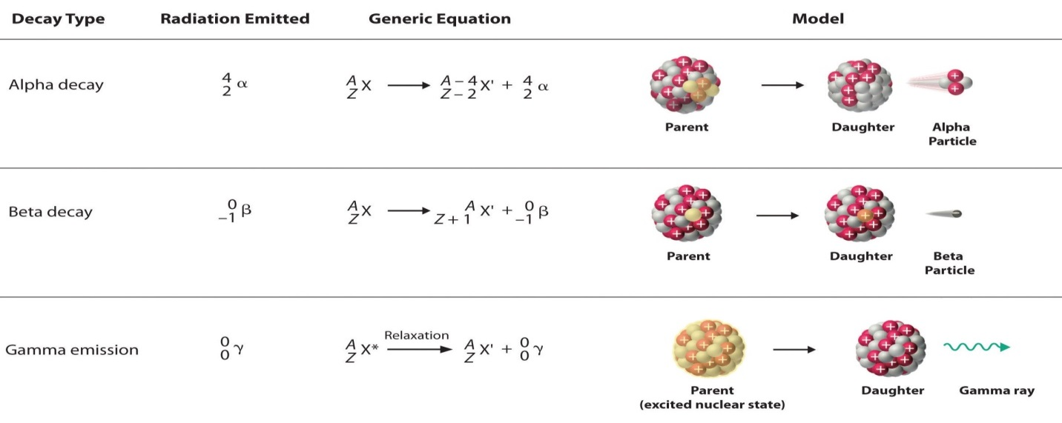
Figure 2.1: Summary of the three types of radiations (James et al., 2014).

Different types of radiation exhibit distinct penetration abilities and travel distances, which depend on their energy and mass. As illustrated in Figure 2.2, alpha particles can be stopped by paper, while beta particles can comfortably penetrate through paper only to be blocked by Perspex. In contrast, gamma emission can penetrate both paper and Perspex; however, they can be shielded effectively by thick lead.

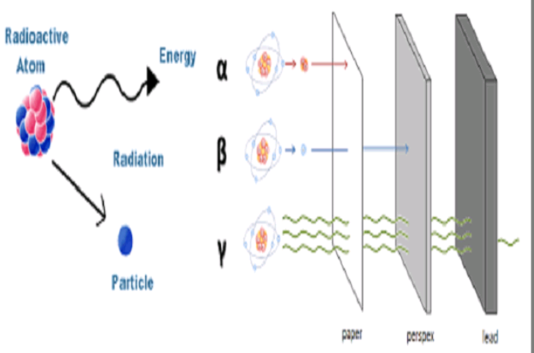
Figure 2.2: Movement and absorption power of alpha beta and gamma radiations (James et al., 2014).

2.2.3 Gamma Decay
Gamma decay comes up as a result of an unstable nuclei shifting from energetic state to a depleted one, releasing gamma rays in the process. Typically, gamma decay occurs alongside alpha or beta decay. Unlike alpha and beta decay, which expel fragments from the nucleus, gamma decay engages in the discharge of electromagnetic waves with very high energy (Barish et al., 2020). Although they possess the greatest penetrating ability compared to alpha and beta particles, the high energy photons have the lowest ionizing power (Bagher et al., 2014).

2.3 Interaction of Gamma Rays with Matter
Crouthamel et al., (2013) state that gamma rays primarily ionize materials through indirect ionization. While several interaction mechanisms exist, three primary ways matter interacts with gamma rays are recognized.

2.3.1 Photoelectric Effect
This process involves the expulsion of electrons from the surface of a metal when illuminated by light of a sufficient frequency (Jho et al., 2023). The electrons generated in this manner are referred to as photoelectrons. The quantity of photoelectrons produced is influenced by the fervor associated with the incoming radiation (Grupen et al., 2010). According to Einstein, the energy of the emitted electron can be expressed using Equation (2.2).

$E=hf-E_{B}$ (2.2)

Where h is the Planck’s constant, f is the frequency of incident radiation and E_{B} is the work energy or the least possible energy required to dislodge an electron from a metal surface (Einstein et al., 2023). Figure 2.3 shows an illustration of photoelectric effect.

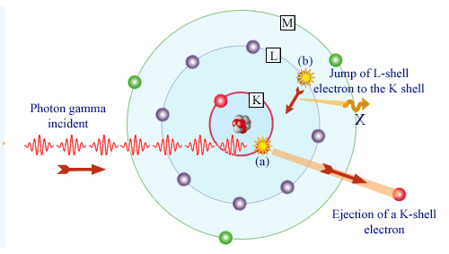
Figure 2.3: Photoelectric effect (Podgorsak et al., 2010)

2.3.2 Compton Scattering
As noted by Norton et al., (1994), Compton scattering occurs when a low-energy photon from an isotope interacts with a lightly held electron, resulting to an increase in the wavelength between the initial and scattered photons. This interaction also causes a change in direction and a loss of energy (Parks et al., 2015). The photon counts associated with Compton scattering are affected by three key factors: the degree of electron activity, the electron number density, and the attenuation coefficient. Figure 2.4 depicts the Compton Effect.

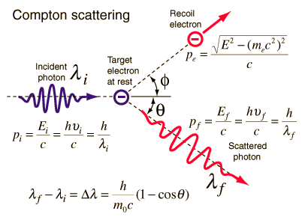
Figure 2.4: Compton effect (James et al., 2014).

The scattered photons exhibit a longer wavelength due to the relationship between energy and wavelength, which is also influenced by the angle of deflection of the X-rays. The wavelength shift, which increases with the scattering angle, is described by Equation (2.3).

$λ^{'}- λ = \left(\frac{h}{mc}\right)\left(1 - cos θ\right)$ (2.3)

where h is Planck’s constant, m is the mass of an electron at rest, c is the speed of light and θ is the angle through which the photon is scattered (Einstein et al., 2023).

2.3.3 Pair Production
A phenomenon which entails changeover of a quantum in to a couple of particles, specifically an electron and its antiparticle, the positron. The kinetic energy associated with this process is expressed as follows (Equation (2.4) (Einstein et al., 2023):

$E=hf-2mc^{2}$ (2.4)

In Equation (2.4), m stands for the mass of an electron, while c is the speed of light, and hf denotes the energy associated with the incoming radiation (Einstein et al., 2023). The nucleus remains in its ground state, showing only a minimal change in its kinetic energy and momentum, without any alteration in its state before and after the interaction. As noted by Roth et al., (1994), the mass relaxation coefficient is persuaded by the quantum number linked to the material being attenuated, while the atomic attenuation coefficient varies directly as the square of the proton number (Chandrasekhar et al., 1990). Figure 2.5 shows how a pair production can be found.
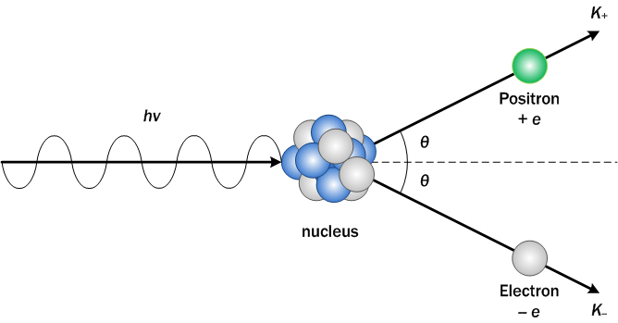
Figure 2.5: Pair production (James et al., 2014).

2.4 Transmission of Gamma Rays through Matter
Immediately a gamma emission collides with an electron orbiting an atom, it ejects an electron from its orbit. Among alpha and beta radiation, gamma rays possess the greatest penetrating ability. As gamma radiation traverses’ matter, it ionizes the material through processes such as the photoelectric emission, Compton scattering, or pair production. Since they possess elevated penetrating ability, high-energy quanta emissions are considered oxidizing radiation and can be lethal to humans, posing a risk to internal organs and bone marrow (Ray et al., 2015).

2.5 Uranium-232 Decay
Uranium has three naturally occurring isotopes: ²³⁴U, ²³⁵U, and ²³⁸U. The International Atomic Energy Agency (IAEA) notes that uranium (Akweetelela et al., 2020), possesses a low specific activity. During its natural decay process, uranium primarily emits alpha particles, with minimal beta and gamma radiation produced. Trace amounts of uranium can be found in various natural sources, including rocks, soil, water, and air. Concentrations tend to be higher in soils located near phosphate deposits, while airborne dust contains uranium as well. On average, an individual is estimated to intake approximately 1.3 micrograms of uranium daily through respiration and consumption (UNSCEAR, 2000). Figure 2.6 illustrates how uranium decays (Zahariman et al., 2016), until a stable nuclide is formed.

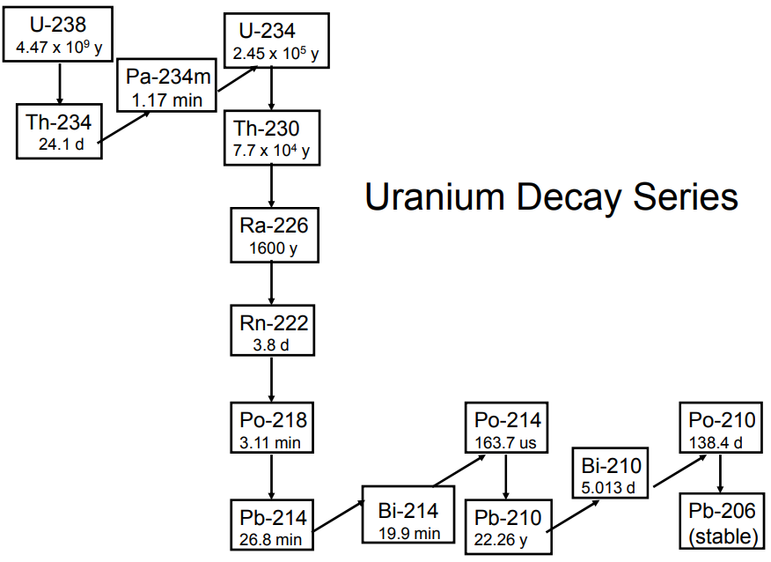
Figure 2.6: Uranium radioactive series (Gilmore et al., 2008).

2.6 Thorium-232 Decay
Thorium is a radioactive metal which occurs naturally (Bhatti et al., 2012) and predominantly on soil, rock, and water (Fesenko et al., 2021). The most stable isotope of thorium, ²³²Th, is generated through the radioactive disintegration of uranium with a span of approximately 14.05 billion years (Higgins et al., 2018). During its decay process, it emits an alpha particle, transforming into radium-228. The decay series concludes with the stable daughter isotope, lead-208 (²⁰⁸ Pb) (Del Guerra et al., (2019. Figure 2.7 illustrates the decomposing process of thorium-232.
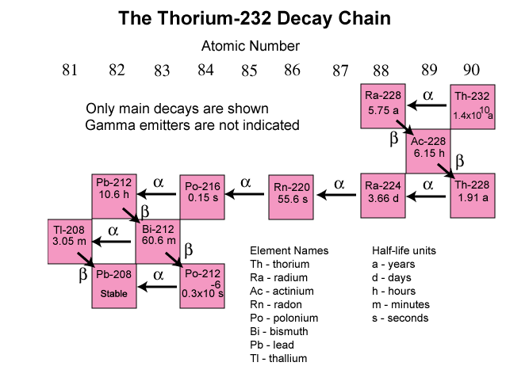
Figure 2.7: Thorium radioactive sequence (Gilmore et al., 2008)

2.8 Gamma-Ray Spectrometry
This is strategy employed for quantitative analysis of energy frequency distributions produced by gamma-ray origins in fields like astronomy, geology, and the nuclear industry (Heusser et al., 1994). Radioactive sources typically emit gamma rays with different energies and intenseness. Once such emissions are discovered and diagnosed using an energy-graduated gamma spectroscopy network, they produce a gamma-ray spectral energy (Minty et al., 1977). This process usually involves assigning specific energy values to each channel after calibrating the detector with precise energy peaks from an IAEA standard reference sample. The resulting gamma range is crucial for locating and quantifying the gamma emitters in a given source (Hendriks et al., 2001), as it is unique to each gamma source.

2.8.1 NaI(Tl) Gamma-Ray Spectrometer
NaI(TI) is one of the most widely used and established scintillator materials for detecting low- to intermediate-energy gamma rays. This system is connected to a Multichannel Pulse Analyzer (MCPA) card along with corresponding software to collect and analyze spectral data. The MCA includes a charge-sensitive preamplifier, a molding amplifier, a high potential difference supply (Newcomer et al., 1993), in conjuction with an analog-to-digital converter (ADC) that operates at 80 MHz. A schematic representation of a typical NaI(Tl) detector is illustrated in Figure 3.2.

HIGH VOLTAGE POWER SUPPLY
PM BASE NaI(T1) DETECTOR
PREAMPLIFIER
MCPA
PC

Figure 2.8; Schematic diagram of NaI (TI) gamma-ray spectrometer (Munyao et al., 2020).

2.8.2 The Gamma-ray Spectrometer's Specifications
A Thallium dopped sodium iodide gamma-ray indicator was employed to discover and compute the high energy emitting isotopes present in the geological samples (Karuppasamy et al., 2024). The spectrometer consisted of a 3" x 3" NaI(Tl) scintillation pointer linked to a multichannel analyzer (ORTEC) for storing and recording the spectrum (Ramasamy et al., 2024). Surrounding the detector is a lead screen with a depth of 10 mm (Abbaspour et al., 2010), which protects it from unwanted background radiation. The computer connected to the detector is equipped with pre-installed Maestro Ortec software. To minimize measurement errors and backscattering, the geological samples were placed approximately 10 cm away from the lead walls and in direct contact with the detector.

2.8.3 Working Mechanism of NaI (Tl) Detector
When gamma rays interact with a sodium iodide plate, they mostly engage with the electrons bound in K or L levels of the iodide particles (Crouthamel et al., 2013). The energy of the incoming gamma photon causes an electron to be ejected, imparting kinetic energy to it. As the recoil electron traverses the sodium iodide crystal, it cripples through ionization, electrical excitation, and thermal excitation, thereby activating the atoms within the crystal (Sisodiya et al., 2023). During the process of de-excitation, visible light quanta are ejected, where they then strike the photocathode and release photoelectrons through the photoelectric emission (Rolo et al., 2016). The emitted photoelectrons move toward a series of positively charged dynodes, where they are accelerated. This results in an electron cascade along the dynode chain, generating an electrical current that varies directly to the incident gamma ray energy at the positive electrode (Stanik et al., 2024). The Multichannel Pulse Analyzer (MCPA) then receives these pulses and categorize them in regard to their energy, ultimately presenting the information as a spectrum (Islam et al., 2015). Figure 3.3 illustrates the scintillation and photo-multiplication processes.

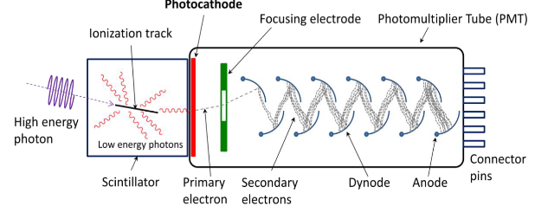

Figure 2.9; Schematic of NaI(Tl) scintillation detector .

CHAPTER THREE: METHODOLOGY

3.1 Study Area.
This research was investigated at specific areas of Mbeere North Sub-County, located in Embu County at the base of Mount Kenya (see Figure 3.1). The region is situated between latitudes 3°15' S and 3°62' S, and longitudes 37°25' E and 38°17' E. It borders Tharaka Nithi County to the north, Kitui to the east, Machakos to the south, Murang’a to the southwest, and Kirinyaga to the west (Mbau et al., 2013). Spanning an area of approximately 777 km², the primary economic activities in the region include the cultivation of food crops and the farming of Miraa as a cash crop. Additional activities consist of brick making, quarrying, tourism, and sand harvesting. This area serves as a significant source of building materials, such as ballast and sand, for the central and eastern regions of Kenya, and the bricks produced here are commonly used in construction within these areas.

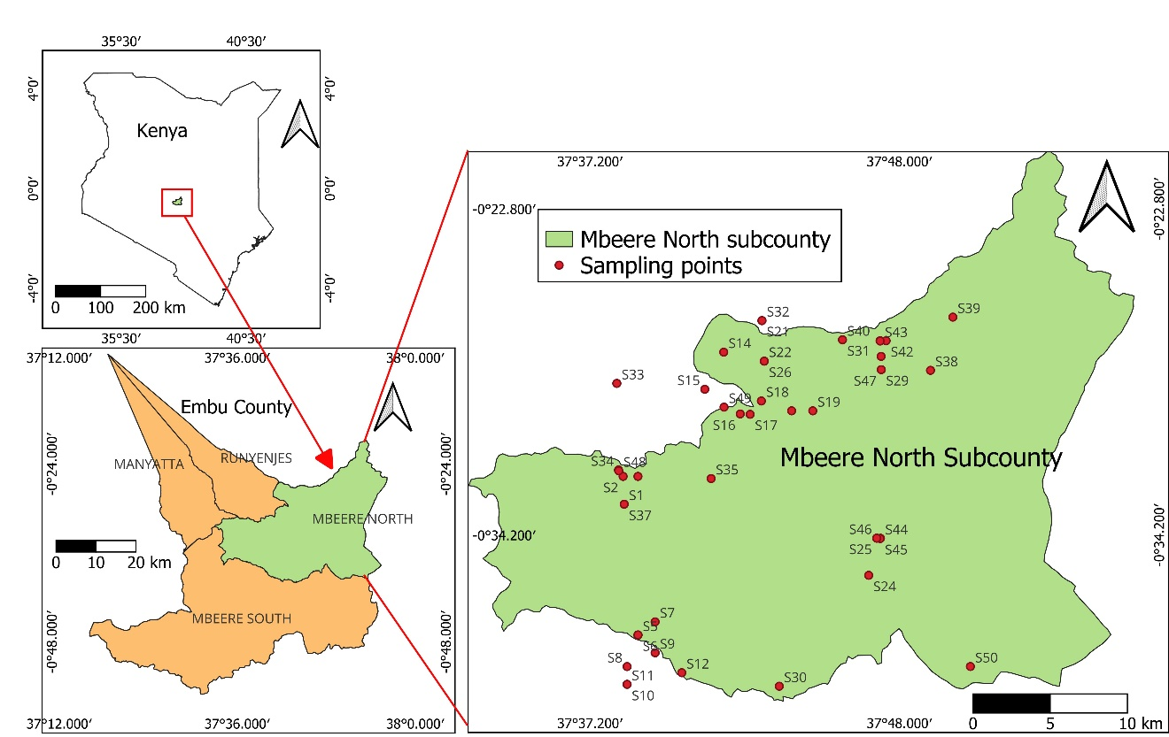
Figure 3.1: Topographic Map of Embu County showing Mbeere North Subcounty showing sampling points.

The Mbeere North region features several hills, including Kiang’ombe (1804 m), Ngoce, Kiambita, Kirigo, Kamarandi, and Kivue. It is traversed by three permanent rivers: Thiba, Tana, and Ena. The hills are known to contain various minerals such as graphite, diamonds, migmatites, pegmatites, iron ore, mica, and gemstones (Githenya et al., 2020). The geological formations in this area are classified into four groupings (Ireri et al., 2022): the Archaean rocks of the basement system, the Embu series, Tertiary volcanics, and skin-deep reserves from the Pleistocene and newest periods. The basement complex is characterized by a diverse range of calcareous rocks, gneisses, and schists (Mwangi et al., 1988). These rocks have undergone granitization and pneumatolysis, leading to the formation of granites, migmatites, and sporadic minerals such as tourmaline, phlogopite, scapolite, and beryl. South of Siakago, there is an abundance of non-granitized rocks (Schoeman et al., 1951).

The rocks of the Embu series include calcareous (friable saccharoidal limestone) and psephitic types (meta-conglomerate, politic, and semi-pelitic), which consist of knotenschiefer, granulose, schistose, gneissose, and semi-hornfelsic varieties. Limestones are present but poorly exposed and found west of the Thura River. Typical knotenschiefer formations are composed of quartz, plagioclase, biotite, muscovite, scapolite, epidote, calcite, and accessory minerals. The soils in this region vary according to rainfall patterns, underlying geological formations, and local drainage conditions (Were et al., 2023). The basement system is covered by pale reddish or brownish sandy and granular soils resulting from semi-arid weathering conditions. These immature soils are rich in quartz, feldspar, and mafic materials (Schoeman et al., 1951). Black cotton soil is only found in a few locations (Musa et al., 2006). Kiang’ombe hill, the highest in the region (John et al., 2015), is encircled by a semi-humid to dehydrated Kenyan Agro Ecological Zone (AEZ) (Kigomo et al., 2018). It covers approximately 2000 hectares of primarily native forest, having about 5% of the area consisting of foreign plantations, mainly located at the base as well as at the summit of the hills present (Kigomo et al., 2018). Recently, the Embu County Government (ECG) announced the discovery of copper deposits in Mbeere.

3.2 Materials and Equipment used.
The study utilized fifty containers of capacity 250 cm³, labeling stickers, mobile phone with GPS application for collection of global coordinates of the sampled sites, oven, shovel for scooping of soil samples, packaging tapes, mesh sieves of different diameters, Sodium iodide indicator, Principal Component Analysis (PCA) package, marker pens, IAEA certified references samples, digital weighing machine for weighing of soil samples, Aluminum foils for ensuring tight seal to ensure the radon does not leak during storage and Vinyl tape for reinforcing the aluminium foils seal.

The study employed fifty containers with a capacity of 250 cm³, labeling stickers, a mobile phone equipped with a GPS application for collecting global coordinates of the sampling sites, an oven, a shovel for scooping soil samples, packaging tapes, mesh sieves of various diameters, a sodium iodide activated with thallium detector, PCA-P software, marker pens, IAEA-certified reference samples, a digital weighing scale for weighing soil samples, aluminum foils to ensure a tight seal to prevent radon leakage during storage, and vinyl tape for reinforcing the seal of the aluminum foils.

3.3. Sampling, Sample Gathering, and Sample Preparedness
This study employed a random sampling technique, which effectively creates a balanced subset that best represents the broader study area (Segerstrom et al., 2004). The distance between sampling sites varied but was consistently maintained within a range of 4 to 5 km. Special attention was given to areas engaged in brick-making. In cases where brick-making sites were distanced apart, soil samples were collected from regions with other anthropogenic activities, such as quarrying, sand harvesting, and farming of crops like Catha edulis (khat), cowpeas, sunflowers, and green grams. The global zone for all selected site were resolved with the help of a GPS (Tukhtaev et al., 2024). Fifty soil samples, each approximately 1000 g in weight and taken from a deepness of around 10 cm (Okeyode et al., 2007), were collected from the selected sites of the Mbeere North region. A composite representative sample weighing roughly 1000 g was created by combining three soil samples of about 350 g each from each sampling location. These samples were collected from a one-meter by one-meter area. Different-sized sieves were used to remove extraneous materials such as plant debris, lumps, and stones amongst the samples (Ogundele et al., 2022). To prevent contamination, it was necessary to store the samples in polyethene bags, labeled with the site name and sample number to eliminate any chances of cross-contamination (Cando‐Dumancela et al., 2023).
The samples were then taken to Tharaka University laboratory, where they were crushed into a fine powder and sieved through a 1 mm mesh sieve (Alhayani et al., 2022). The sieved samples were scorched in an oven set at 110 °C for eight hours to eliminate any water content. After cooling, the samples got weighed, then placed in 250 cm³ plastic vessels, and hermetically sealed. To permit ²²⁶Ra, ²³²Th, and their short-lived decay products to stabilize, they were kept for at least 30 days before counting (Ramasamy et al., 2009). The radioisotopes within the samples were uncovered using a NaI (Tl) gamma-ray detector and associated electronics at South Eastern University of Kenya.

3.4 Requirement Prior to Sample Counting
This includes detector energy calibration, detector counting resolution and efficiency as well as the background radiation measurements.

3.4.1 NaI (TI) Detector Energy Fine-Tuning
Energy graduation of the detector is necessary to enable among them conversion of channel numbers into energies, a critical step for detecting target radioisotopes within the sample. The pre-equipped radionuclide library in the Maestro application associates various radioactive isotopes with corresponding energies belonging to them; thus, accurately assigning energy to the appropriate channels allows for the identification of the relevant radionuclide (Gilmore et al., 2008). The Ortec program was used to capture the spectrum of a high-activity multi-nuclide sample containing a mix of Americium-241, Caesium-137, and Cobalt-60, according to the IAEA. This standard source came about not only for its availability but also for the well-resolved peaks it generates, with an energy range from 59.5 keV for ²⁴¹Am to 1332 keV for ⁶⁰Co (Scafe et al., 2007), which overlaps with the energy range of the radionuclides under investigation (²¹²Pb at 239 keV to ⁴⁰K at 1460 keV).

The energy distribution obtained from the reference sample got used to make certain that each channel of the Multichannel Pulse Analyzer (MCPA) is accurately calibrated to the corresponding energy. A two-dimensional polynomial regression was employed to change each channel into energy values, as illustrated in Figure 3.2.

Figure 3.2; Results of energy calibration
The model shows a perfect fitting ($R^{2}=1)$ indicating that the 2nd order polynomial adequately describes the relationship between channel number and photon energy (Malain et al., 2010).

3.4.2 Detector Counting Resolution and Efficiency
The performance linked to a detector is primarily influenced by three factors (Hosang et al., 2015). Detector Size: The accuracy of a detector is dependent on its dimensions. A larger detector increases the volume available for gamma-ray interaction and absorption. The efficiency of detecting ionizing radiation is affected by the spatial arrangement of the detector, the source, and the distance between them. Marinelli beakers are advantageous because they provide a favorable geometry for the source and detector setup. Furthermore, the entrance window material of the detector should be thin to reduce the attenuation of incoming gamma rays.

Understanding the detection efficiency (ε) (Pace et al., 2011), simplifies the calculation of the activity (A) of a sample based on the count of detected particles (N). The photo-peak efficiency for detecting isotopes ²³⁸U, ²³²Th, and ⁴⁰K was assessed using Certified Reference Materials (CRM) from the RG-series, which are verified by the International Atomic Energy Agency (IAEA) as RGK⁻¹, RGU⁻¹, and RGTh⁻¹ (Pourimani et al., 2021) This efficiency was calculated using Equation (3.1) (Matsitsi et al., 2020).

$η = Np A.Pγ.t$ (3.1)

In Equation (3.1), Eγ denotes the specific energy of the gamma-ray, and η represents the detection efficiency at the photo peak. The activity of the standard source is indicated by 𝐴 in Becquerels (Bq), while 𝑁𝒑 refers to the remaining gamma-ray census observed at the peak energy. The International Atomic Energy Agency (IAEA, 2004) provided standard gamma decay probabilities, which are as follows: 0.3534 for ²¹⁴Pb at 351 KeV, 0.4516 for ²¹⁴Bi at 609 KeV, 0.4316 for ²¹²Pb at 238 KeV, 0.258 for ²²⁸Ac at 911 KeV, and 0.1066 for ⁴⁰K at 1460 KeV. The counting time, denoted as 𝑡 (in seconds), was used to calculate the counting efficiency, resulting in values of 0.079951, 0.046952, and 0.021031 for ²³²Th, ²³⁸U, and ⁴⁰K, in that order, based on activities of 3250, 4940, and 14000.
Detector resolution reflects a detector's ability to distinguish between two energy peaks that are closely spaced. It is quantified by the Full-Width at Half Maximum (FWHM) coupled to each energy climax at a given energy and can be expressed either in absolute keV or as a percentage (Cibrario et al., 2024). A high detector resolution is crucial for accurate identification of radionuclides (Reguigui et al., 2006). For instance, the energy resolution for the 662 keV gamma ray from Cs-137 using a NaI(Tl) detector typically ranges from 7.5% to 8.5% (Knoll et al., 2010). In this investigation, the resolution for Cs-137 at 663.35 keV was determined to be 6.6%.

3.4.3 Background Correction
Background counts were measured by performing gamma ray counting on a demineralized water specimen for a duration equal to that of the environmental samples. The net count is calculated by deducting the deionized water clicks out of the environmental samples counts (Marie et al., 1999).

3.5 Radiometric Variables
This comprises the danger indices (internal, external, and radium equivalent), equivalent concentration, absorbed dose rate, alongside with effective dose rates per year (both internal and external).

3.5.1 Activity Concentration
The radiation gauge of ²³²Th, ²³⁸U, as well as ⁴⁰K got computed using the spectral data analyzed with Ortec software. The activity of the geological samples (As), based on their mass (Ms) and photopeak intensity (Is), was determined using the comparison strategy implied in Equation (3.2) (Addo et al., 2013).

$A_{s}=\frac{A_{R}M_{R}I_{s}}{I_{R}M_{s}}$ (3.2)

In equation (3.2), the subscript R, denotes parameters of the reference sample.

3.5.2 Absorbed Dose (AD)
The absorbed dose measures the energy preoccupied by a one kilogram of a substance when exposed to harmful radiation. To calculate the absorbed dose, the activity-dose alteration coefficients of 0.427, 0.662, and 0.043 (nGy⁻¹ per Bqkg⁻¹), as reported by UNSCEAR 2000 and outlined in Equation (3.3) (Ramasammy et al., 2019), were utilized.

$AD=0.427C_{Ra} + 0.662C_{Th} +0.043C_{K}$ (3.3)

Where: C_{Ra}, C_{Th}, and C_{K} are the moderate activity absorptions of ²³⁸U, ²³²Th, and ⁴⁰K in Bqkg⁻¹, for each contained in the homogeneous sample of the soil samples (Ramasammy et al., 2019).

3.5.3 Annual Effective Dose (AED)
The annual equivalent dose (AED) serves as an indicator of an individual's total radiation risk. The calculation of AED was predicated on the assumption that, on average, an adult in Kenya spends approximately 60% of their time indoors and 40% outdoors (Mustapha et al., 1999). Globally, the common residency constants for indoor and outdoor context are 0.2 and 0.8, respectively (Dhiman et al., 2024). In Kenya, occupancy factors of 0.6 for indoors and 0.4 for outdoors are utilized to assess the internal and external annual effective doses. Equation (3.4) (Charles et al., 2019), was applied to compute the AED.

$AED = D × T × Q × {10}^{-6}$ (3.4)

This equation includes variables such as the absorbed dose (D), the residency time (T), and the dose transformation constant(Q), which changes the absorbed dose in the surrounding into an effective dose for humans. Given that the occupancy factors differ for indoor (0.6) and outdoor (0.4) environments (Frontczak et al., 2011), the annual effective dose (AED) worked out using Equations (3.5) together with (3.6) (Hafezi et al., 2005).

${ AED}_{in}(mSvy^{-1})=D (nGyh^{-1})×8760(h y^{-1})×0.6×0.7(SvGy^{-1})× {10}^{-6}$ (3.5)

${AED}_{out}(mSvy^{-1})=D (nGyh^{-1})×8760(h y^{-1})×0.4×0.7(SvGy^{-1})×{10}^{-6}$ (3.6)

In this context, AED_{in} and AED_{out} represent the yearly effective doses for indoor and outdoor atmospheres, following that order (Panghal et al., 2018). The absorbed dose is denoted by D, and the yearly duration of hours is 8,760 nGhy⁻¹. The dose changeover factor is 0.7 (SvGy⁻¹), while the occupancy factors for indoor and outdoor spaces are 0.6 (60%) and 0.4 (40%), following that order (UNSCEAR, 2000).

3.5.4 Radium Equivalent (Ra_{eq})
Based on the presumption that gamma dose rates for 1 BqKg⁻¹ of ²²⁶Ra, 1.428 BqKg⁻¹ of ²³²Th, and 0.077 BqKg⁻¹ of ⁴⁰K are equal, radium equivalent was determined (Beretka et al., 1985). The empirical relationship used to determine the radium equivalent is shown in Equation (3.7).

${Ra}_{eq}=C_{Ra}+1.426C_{Th}+0.0792C_{k}$ (3.7)

Of which C_{Ra}, C_{Th}, and C_{K} represents the concentrations of ²²⁶Ra, ²³²Th, and ⁴⁰K that are specifically active in the soil samples respectively and are expressed in Bqkg⁻¹ (Beretka et al., 1985). Any building material having a Ra_{eq} greater than 370 Bqkg⁻¹ should not be used for human use as it runs the risk of exposing the people to dangerous radiation (UNSCEAR, 1988).

3.5.5 Internal Hazard Index (H_{in})
The Internal Hazard Index (Hin) offers insights into the internal exposure to radon, a known carcinogen, and its short-lived progeny (Bodunrin et al., 2017). This internal exposure occurs when radionuclides, particularly those from the ⁴⁰K, ²³⁸U, and ²³²Th series found in rocks and soil, are inhaled (Tsai et al., 2008). Internal hazard index (Hin) calculation was conducted with the help of Equation (3.8) (Beretka et al., 1985).

$H_{in}=\left(\frac{C_{Ra}}{185} \right)+\left(\frac{C_{Th}}{259}\right)+\left(\frac{C_{K}}{4810}\right)$ (3.8)

Wherein the average activity concentrations for ²²⁶Ra, ²³²Th, and ⁴⁰K, all in in BqKg⁻¹ are denoted by C_{Ra}, C_{Th}, and C_{K}, respectively (Beretka et al., 1985).

3.5.6 External Hazard Index (Hex)
The outdoor hazard pointer measures the additional gamma radiation originating from sources such as construction tools. For radiation to have meaningless harmful repercussions towards the general population, the external hazard indicator must remain below 1, which equivalent to a highest radium-equivalent activity of 370 Bqkg⁻¹ (Al-Zahrani et al., 2017). The calculation of the external danger pointer (Hex) is demonstrated in Equation (3.9).

$Hex= \frac{A_{Ra}}{370} +\frac{A_{Th}}{259}+\frac{A_{K}}{4810}$ (3.9)

Where; A_{Ra}, A_{Th}, and A_{K} are the specific mean activity concentrations of radionuclides ²²⁶Ra, ²³²Th and ⁴⁰K in Bqkg⁻¹(Al-Zahrani et al., 2017).

3.6 Ethical Considerations
The study strictly followed the ethics guidelines. Clearance certificate from Ethics Committee of Chuka University, research permit from NACOSTI and administrative permission from relevant authorities in the field were also acquired. The introduction letter was also acquired from the graduate school of Tharaka University. The researcher’s intention was fully explained to the respondents and their consent sought before specimens (soil samples) were collected. The interviewee was sensitized on their right to withdraw or refuse to disclose any information they would not want to divulge. Experimental guidelines were adhered to without data manipulation of procedure and data. The originality and authenticity of data and information was considered and the document was subjected to Turnitin checker. The organization of the proposal and thesis is in line with the Tharaka University Graduate School students’ handbook. The results will be communicated to the relevant parties whenever required.

CHAPTER FOUR: RESULTS AND DISCUSSIONS

4.1 Activity Absorptions of ²³²Th, ²³⁸U and ⁴⁰K
This measurement indicates amounts of radioactive material in the mass of a sample, which is utilized to evaluate the strength of a radioactive source in a specific environment. In this study, the gamma-ray count rates of ²³²Th, ²³⁸U, and ⁴⁰K in the soils (Merdanoğlu et al., 2006), from selected areas of the Mbeere North region were assessed. The resulting concentrations were then evaluated in Bqkg⁻¹ using the comparative method, as outlined in Equation (3.2). The activity concentrations obtained from the collected samples are summarized in Figures 4.1, 4.2, and 4.3, as well as in Table 4.1.

Table 4.1: Activity concentration ²³²Th, ²³⁸U and ⁴⁰K
Site code | Sampling site | Activity concentration (BqKg⁻¹)
Site code | Sampling site | ²³²Th | ²³⁸U | ⁴⁰K
SS1 | Siakago Boys | 240.59±3.48 | 140.20±2.70 | 329.65±33.92
SS2 | Mwondu | 141.48±3.31 | 82.20±2.56 | 255.71±33.21
SS3 | Siakago Girls | 163.15±3.27 | 95.06±2.51 | 507.63±32.72
SS4 | Witwa | 153.77±2.51 | 95.78±2.41 | 1127.53±38.14
SS5 | Mumburi | 84.57±2.58 | 60.50±2.23 | 258.99±33.74
SS6 | Kamugu Primary | 80.60±2.47 | 50.84±2.10 | 280.84±34.69
SS7 | River Thura Bank | 94.50±2.59 | 58.39±2.16 | 642.13±35.51
SS8 | Kathagari | 75.35±2.63 | 48.31±2.23 | 538.26±37.33
SS9 | Karimari | 89.18±2.53 | 58.56±2.13 | 356.42±35.55
SS10 | Gitua | 374.14±3.38 | 202.98±2.76 | 499.89±39.44
SS11 | Kavugua | 113.43±2.68 | 70.57±2.24 | 424.46±36.52
SS12 | Gangara | 90.86±2.58 | 58.40±2.14 | 748.80±35.69
SS13 | Itiira Pry | 68.06±2.61 | 43.55±2.23 | 281.87±36.53
SS14 | Kanyuambora | 329.20±3.26 | 179.43±2.65 | 375.63±37.91
SS15 | Gatungaru | 312.29±3.09 | 201.64±2.59 | 407.75±36.60
SS16 | Gitie Pry | 132.97±2.70 | 79.65±2.24 | 263.90±35.69
SS17 | River Ena Bank | 184.33±2.81 | 122.32±2.37 | 311.60±35.76
SS18 | Kamumu Full Gospel | 122.17±2.61 | 70.32±2.18 | 469.83±34.94
SS19 | Bahati Kagumo | 152.66±2.80 | 85.13±2.27 | 635.56±36.28
SS20 | Kathiga-Gaceru | 130.65±2.76 | 80.28±2.26 | 412.65±36.02
SS21 | Gatororori Pri | 134.98±2.81 | 81.17±2.27 | 450.27±36.49
SS22 | Kirigo Hill | 79.33±2.60 | 58.77±2.16 | 406.08±34.55
SS23 | Mugwanjogu Market | 94.08±2.74 | 63.69±2.26 | 319.43±36.38
SS24 | Rwanjogu River Bank | 122.16±2.73 | 82.09±2.53 | 660.03±35.65
SS25 | Iriaitune | 81.87±2.62 | 57.49±2.15 | 1155.28±35.82
SS26 | Marivwe River Bank | 115.11±2.68 | 73.85±2.19 | 440.43±35.24
SS27 | Kamigua Pry | 25.14±2.42 | 20.66±2.01 | 210.90±33.54
SS28 | Usambara Pry | 55.72±2.61 | 38.52±2.16 | 185.32±36.07
SS29 | St Paul Minimax Centre | 236.20±3.08 | 146.47±2.55 | 400.79±35.41
SS30 | Miangeni | 94.80±2.64 | 70.85±2.32 | 389.19±34.67
SS31 | Gwakaithi | 369.62±2.32 | 189.70±2.65 | 315.60±36.65
SS32 | Karigiri | 153.49±3.67 | 76.26±2.38 | 661.98±33.51
SS33 | Kiang'ombe Hill | 129.25±3.34 | 68.52±2.42 | 797.20±35.22
SS34 | Kiang'ombe Hill | 214.19±2.65 | 109.45±2.62 | 940.70±36.04
SS35 | Family Worship Church | 279.51±1.86 | 164.00±2.91 | 580.56±36.61
SS36 | Magacha | 148.27±2.92 | 89.94±2.52 | 768.28±32.39
SS37 | Kanjara | 158.34±3.02 | 95.28±2.61 | 610.37±33.69
SS38 | Tana River Bank | 207.37±3.19 | 127.59±2.76 | 861.93±34.11
SS39 | Kanyua B | 65.10±2.61 | 39.70±2.32 | 285.62±32.01
SS40 | Ciangera | 34.19±2.64 | 21.53±2.35 | 186.47±33.30
SS41 | Mbarwari | 87.78±2.74 | 57.91±2.39 | 562.77±32.72
SS42 | Karerema Market | 86.08±2.72 | 49.36±2.43 | 539.34±36.12
SS43 | Kigwambiti | 129.67±2.76 | 75.65±2.45 | 386.26±34.52
SS44 | Kirie Market | 184.45±2.91 | 101.18±2.53 | 397.75±35.55
SS45 | Kiriari | 327.37±3.22 | 181.37±2.75 | 587.42±34.71
SS46 | Kamarandi | 133.97±2.76 | 77.51±2.45 | 456.04±34.75
SS47 | Wonderland Ishiara | 256.98±3.11 | 125.81±2.68 | 320.11±36.39
SS48 | Kune | 122.36±2.75 | 54.14±2.30 | 599.90±35.26
SS49 | Gitie | 123.59±2.73 | 69.59±2.42 | 526.53±35.19
SS50 | Gitua River Bank | 101.85±2.68 | 64.95±2.41 | 385.76±34.32
 | Mean | 149.74±2.82 | 88.34±2.39 | 490.35±35.24
 | Max | 374.14±3.38 | 202.98±2.76 | 1155.28±35.82
 | Min | 25.14±2.42 | 20.66±2.01 | 185.32±36.07

Figure 4.1 Activity concentration of ²³²Th in the dirt samples

Figure 4.2: Activity concentration of ²³⁸U in soil samples.
Figure 4.3: Activity concentration of ⁴⁰K in the samples

The equivalent concentration of ²³²Th ranged between 25.14±1.86 Bqkg⁻¹ for the sample collected at Kamigua primary school to 374.14±3.48 Bqkg⁻¹ for the sample collected at Gitua. Soil collected from Kamigua primary school also recorded the lowest concentration of ²³⁸U with 20.66±2.01 Bqkg⁻¹ while the sample from Gitua also recorded the highest concentration of ²³⁸U at 202.98±2.91 Bqkg⁻¹. The activity concentrations of ⁴⁰K were between 185.32±32.02 Bqkg⁻¹ at Usambara Primary School and 1155.28±35.82 Bqkg⁻¹ at Iriaitune. From the location of the sampling points presented in Figure 4.1, it clear that although the sample from Gitua showed the highest concentration of ²³²Th and ²³⁸U of 374.14±3.38 Bqkg⁻¹ as well as 202.98±2.76 Bqkg⁻¹ singly, and that from Iriaitune the highest concentration of ⁴⁰K of 1155.28±35.82 Bqkg⁻¹, the neighboring sites such as Kathagari, Karimari, Kavugua and Itiira primary school neigbouring Gitua and Marivwe, Rwanjogu and Mugwanjogu neigbouring Iriaitune, did not show comparatively high radionuclide activity. This sample (at Gitua) was collected on River Gitua which is a seasonal river. The high concentrations amongst the radioactive isotopes ²³²Th and ²³⁸U perhaps is attributed to weathering and wearing away (Tamilarasi et al., 2024), from the rocks in the nearby Kirigo hill. This implies that the said hill contains rocks with traces of radioactive elements.

Similarly, the sample from Kamigua primary school reported the lowest concentration of ²³²Th and ²³⁸U of 25.14±2.42 Bqkg⁻¹ and 20.66±2.01 Bqkg⁻¹ respectively while that from Usambara Primary School which neighbours Kamigua primary school site reported the lowest concentration of ⁴⁰K of 185.32±36.07 Bqkg⁻¹, yet the neighboring sites such as St. Paul Minimax Centre, Marivwe, Iriairune and Miangeni did not show a similar trend. Consequently, the Mbeere North zone displays a heterogenous geometrical dispensation from the tested radioisotopes. When compared to the global averages of 45 Bqkg⁻¹, 33 Bqkg⁻¹, and 420 Bqkg⁻¹ for ²³²Th, ²³⁸U, and ⁴⁰K, respectively (UNSCEAR, 2017), it is notable that all samples, except those from Kamigua Primary School and Ciangera, exceeded the world average for ²³²Th and ²³⁸U. However, some samples showed concentrations of potassium below the global average. These samples likely originated from untouched land, where the influence of potassium-rich fertilizers was minimal, unlike in areas where inorganic fertilizers were heavily utilized.

The moderate effective concentrations for the three elements were measured at 149.74±2.82 Bqkg⁻¹, 88.34±2.39 Bqkg⁻¹, and 490.35±35.24 Bqkg⁻¹ for ²³²Th, ²³⁸U, and ⁴⁰K, in that order. Notably, the average concentrations amid the elements in the sampled locations exceeded the global average levels (Raghu et al., 2020). The high concentrations observed in the samples are likely pegged to the physical setting of the region, of the kind that contains significant amounts linked with weathered granite, phosphate, quartzite, and metamorphic rocks. Additionally, the extraction of sand by both skilled and unskilled laborers through harvesting and quarrying may have contributed to these elevated levels. The region also shows signs of erosion, which has led to the deposition of sediments from the surrounding Kiang’ombe, Kirigo, and Kamarandi hills into the soil. Among the three radionuclides analyzed, ⁴⁰K exhibited higher concentrations than ²³²Th and ²³⁸U. This could be linked to the excessive use of potassium-rich inorganic fertilizers in the tillage of Catha endullis (khat) and other crops in the area (Njagi et al., 2022).

The sampling sites of Family Worship Church and Kune lie on the foot of Kiang’ombe hill. Mugwanjogu market and Rwanjogu river bank are on the foot of Kirigo hill while Kanjara, Kanyua B and Ciangera are on the feet of Kamarandi hills. The radionuclide concentration of soils collected from these sites depict that they are within the average value of the entire Mbeere north region. Therefore, these hills though possessive of rocks of volcanic nature are not laced with radioactive elements. Additionally, it's important to note that the effective concentrations of the sets gathered at the base of the Kamarandi hills are lower in comparison to those from the bases of the Kirigo and Kiang’ombe hills. This discrepancy may be assigned to the reality that, in addition to mining, quarrying, and farming, which are widespread throughout the region, cattle raising is the predominant economic activity in that area.

Samples SS33 and SS34 were taken from the slopes of Kiang’ombe hill. The elevated activity concentration of ⁴⁰K at these locations may be associated with the excessive application of inorganic manure in the gardening of crops like Catha edulis, wheat, and peas (Ugbede et al., 2021), just to mention a few. Sample SS22 was collected from the slopes of Kirigo hill, and the levels of radionuclides from this site fall within the range observed at nearby locations, including Gatororori Primary, Mugwanjogu market, and Kathiga-Gaceru.

Contrasting this study's radionuclide concentrations with those of other comparable investigations in the world is shown on Table 4.2. Among the studies in the comparison is the report of Njagi et al., (2022) in the expansive Embu County and that of Kamunde et al., (2016) in the neighboring county of Tharaka Nithi.

Table 4.2: Linkage of activities in Soil in this probe with parallel studies.
Sampling area | ²³⁸U  (Bqkg⁻¹) | ²³²Th  (Bqkg⁻¹) | ⁴⁰K  (Bgkg⁻¹) | Reference
Mbeere North, Kenya | 88.34±2.39 | 149.74±2.82 | 490.35±35.24 | This Study
Kakamega, Kenya | 80±4 | 200±10 | 968±48 | Songa et al., 2021
Tharaka Nithi, Kenya | 53 ± 3 | 96 ± 4 | 1069 ±46 | Kamunde et al., 2016
Embu County, Kenya | 33 ±5 | 22 ±11 | 344±12 | Njagi et al., 2022
Pakistan | 26 | 39 | 485 | Rahman et al., 2007
Imo State, Nigeria | 4.15 | 1.64 | 134.13 | Mbonu et al., 2021
World average | 33 | 45 | 420 | UNSCEAR, 2008

Mbeere North exhibits a slightly elevated concentration of ²³⁸U compared to other regions, while the levels of the other radionuclides fall within ranges documented in previous studies. However, when compared to findings from the entire Embu County, the Mbeere North region demonstrates higher concentrations of all three radionuclides of interest. As anticipated, the concentration of ⁴⁰K varies considerably across different geographical areas, which can be attributed to the diverse anthropogenic actions, like farming, conducted in those locations. Overall, the results of this study align well with those from similar research. The increased levels of ²³⁸U may be linked to the presence of graphite, diamonds, migmatites, pegmites, iron ore, mica, and gemstones (Mahon et al., 2022), found in the Mbeere North region.

4.2 Absorbed Dose and Annual Effective Dose Rates
The annual effective dose rate (AED) for an individual reflects their overall radiation exposure throughout the year. Based on AED calculations, an average adult Kenyan is estimated to spend about 60% of their time indoors (approximately 14.4 hours per day) and 40% outdoors (around 9.6 hours per day). These percentages were derived from the activity concentrations measured in this research, utilizing Equation (3.3) for absorbed dose and Equations (3.5) and (3.6) for indoor and outdoor effective dose rates per annum, respectively. Values accompanying absorbed dose along with internal and external annual effective doses, are summarized in Table 4.3. Additionally, the fate is portrayed in Figures 4.4, 4.5, and 4.6.

Table 4.3: Absorbed dose and annual effective dose rates.
Site code | Sampling Site | Absorbed dose  AD (nGyh⁻¹) | AEDRin (mSvy⁻¹) | AEDRout (mSvy⁻¹)
SS1 | Siakago Boys | 233.31±4.92 | 0.86±0.02 | 0.57±0.01
SS2 | Mwondu | 139.75±4.71 | 0.51±0.02 | 0.34±0.01
SS3 | Siakago Girls | 170.43±4.64 | 0.63±0.02 | 0.42±0.01
SS4 | Witwa | 191.18±4.59 | 0.70±0.02 | 0.47±0.01
SS5 | Mumburi | 92.96±4.11 | 0.34±0.02 | 0.23±0.01
SS6 | Kamugu Primary | 87.14±4.03 | 0.32±0.01 | 0.21±0.01
SS7 | River Thura Bank | 115.10±4.16 | 0.42±0.02 | 0.28±0.01
SS8 | Kathagari | 93.65±4.30 | 0.34±0.06 | 0.23±0.01
SS9 | Karimari | 99.37±4.11 | 0.37±0.02 | 0.24±0.01
SS10 | Gitua | 355.85±5.11 | 1.31±0.02 | 0.87±0.01
SS11 | Kavugua | 123.48±4.30 | 0.45±0.02 | 0.30±0.01
SS12 | Gangara | 117.29±4.16 | 0.43±0.02 | 0.29±0.01
SS13 | Itiira Pry | 75.77±4.23 | 0.28±0.02 | 0.19±0.01
SS14 | Kanyuambora | 310.70±4.92 | 1.14±0.02 | 0.76±0.01
SS15 | Gatungaru | 310.37±4.72 | 1.14±0.02 | 0.76±0.01
SS16 | Gitie Pry | 133.38±4.28 | 0.49±0.02 | 0.33±0.01
SS17 | River Ena Bank | 187.66±4.41 | 0.69±0.02 | 0.46±0.01
SS18 | Kamumu Full Gospel | 131.11±4.16 | 0.48±0.02 | 0.32±0.01
SS19 | Bahati Kagumo | 164.74±4.39 | 0.61±0.02 | 0.40±0.01
SS20 | Kathiga-Gaceru | 138.52±4.34 | 0.51±0.02 | 0.34±0.01
SS21 | Gatororori Pri | 143.38±4.40 | 0.53±0.02 | 0.35±0.01
SS22 | Kirigo Hill | 95.08±4.13 | 0.35±0.02 | 0.23±0.01
SS23 | Mugwanjogu Market | 103.21±4.34 | 0.38±0.02 | 0.25±0.01
SS24 | Rwanjogu River Bank | 144.30±4.30 | 0.53±0.02 | 0.35±0.01
SS25 | Iriaitune | 128.42±4.20 | 0.47±0.02 | 0.31±0.01
SS26 | Marivwe River Bank | 126.67±4.23 | 0.47±0.02 | 0.31±0.01
SS27 | Kamigua Pry | 34.53±3.90 | 0.13±0.01 | 0.08±0.01
SS28 | Usambara Pry | 61.30±4.16 | 0.23±0.02 | 0.15±0.01
SS29 | St Paul Minimax Centre | 236.14±4.65 | 0.87±0.02 | 0.58±0.01
SS30 | Miangeni | 109.74±4.23 | 0.40±0.02 | 0.27±0.01
SS31 | Gwakaithi | 339.26±4.92 | 1.25±0.01 | 0.83±0.01
SS32 | Karigiri | 162.64±4.34 | 0.60±0.02 | 0.40±0.01
SS33 | Kiang'ombe Hill | 149.10±4.46 | 0.55±0.02 | 0.37±0.01
SS34 | Kiang'ombe Hill | 228.98±4.82 | 0.84±0.02 | 0.56±0.01
SS35 | Family Worship Church | 280.03±4.05 | 1.03±0.01 | 0.69±0.01
SS36 | Magacha | 169.59±4.40 | 0.62±0.02 | 0.42±0.01
SS37 | Kanjara | 171.76±4.57 | 0.63±0.02 | 0.42±0.01
SS38 | Tana River Bank | 228.82±4.76 | 0.84±0.02 | 0.56±0.01
SS39 | Kanyua B | 72.33±4.10 | 0.27±0.02 | 0.18±0.01
SS40 | Ciangera | 39.85±4.19 | 0.15±0.02 | 0.10±0.01
SS41 | Mbarwari | 107.04±4.24 | 0.39±0.02 | 0.26±0.01
SS42 | Karerema Market | 101.26±4.36 | 0.37±0.02 | 0.25±0.01
SS43 | Kigwambiti | 134.75±4.36 | 0.50±0.02 | 0.33±0.01
SS44 | Kirie Market | 182.41±4.53 | 0.67±0.02 | 0.45±0.01
SS45 | Kiriari | 319.42±4.80 | 1.18±0.02 | 0.78±0.01
SS46 | Kamarandi | 141.40±4.37 | 0.52±0.02 | 0.35±0.01
SS47 | Wonderland Ishiara | 237.61±4.77 | 0.87±0.02 | 0.58±0.01
SS48 | Kune | 129.92±4.32 | 0.48±0.02 | 0.32±0.01
SS49 | Gitie | 134.18±4.36 | 0.49±0.02 | 0.33±0.01
SS50 | Gitua River Bank | 111.74±4.28 | 0.41±0.02 | 0.27±0.01
 | Mean | 157.93±4.40 | 0.58±0.02 | 0.39±0.01
 | Max | 355.85±5.11 | 1.31±0.02 | 0.87±0.01
 | Min | 34.53±3.90 | 0.13±0.01 | 0.08±0.01

Figure 4.4: Absorbed dose rate of the assembled samples (safe limit -1500nGyh⁻¹).

Figure 4.5: Indoor annual equivalent dose rate of the gathered samples.

Figure 4.6: Outdoor yearly equivalent dose rate of the collected samples.

The data shown in Table 4.3 and Figures 4.4, 4.5, and 4.6 indicate that the soil sample from Gitua exhibited the highest values for absorbed dose, together with indoor and outdoor yearly effective dose rates, measuring 355.85±5.11 nGyh⁻¹, 1.31±0.02 mSvy⁻¹, and 0.87±0.01 mSvy⁻¹, in that order. Conversely, the soil sample from Kamigua Primary School recorded the lowest values at 34.53±3.90 nGyh⁻¹, 0.13±0.01 mSvy⁻¹, and 0.08±0.01 mSvy⁻¹. The average values for absorbed dose, indoor annual effective dose rate, and outdoor annual effective dose rate (Alhayani et al., 2020), were found to be 157.93±4.40 nGyh⁻¹, 0.58±0.02 mSvy⁻¹, and 0.39±0.01 mSvy⁻¹, respectively. All soil samples, except those collected at Kamigua Primary and Ciangera, had absorbed dose rates above the global average of 57 nGyh⁻¹. Nonetheless, all sampled sites reported absorbed dose rates that went far much down as compared to the safe end of 1500 nGyh⁻¹ as recommended by UNSCEAR (2013).
Twelve percent of the fifty samples collected exhibited indoor effective dose rates (AEDin) that exceeded the admissible ceiling of 1 mSvy⁻¹. Such samples were sourced from the Family Worship Church (located at the base of Kiang'ombe Hill), Gitua, Kanyuambora, Gatungaru, Gwakaithi, and Kiriari. However, all collected samples had outdoor annual effective dose rates (AEDout) that remained within acceptable safe limits. This indicates that constructing residential buildings using the soils from the Mbeere North region of Embu County is safe. Generally, the indoor effectual dose rates surpassed the outdoor yearly effective dose rates, reflecting the expected duration of outdoor occupancy for the Kenyan masses.

4.3 Radium Equivalent, Internal and External Hazard Indices
Radium equivalent measures the radiation energy accrued by a unit load of stuff when subjected to a sample containing various nuclides (L’Annunziata et al., 2020). The internal hazard index (Hin) assesses the potential risks associated with radionuclides that can be inhaled or ingested, while the external hazard index (Hex) quantifies the effects of radionuclides that impact matter from the outside. For radiation to be deemed to pose minimal risk to the general society, both the internal and external hazard pointers should be lesser 1 (Zubair et al., 2020), corresponding to a maximum radium-equivalent activity of 370 Bqkg⁻¹. Estimates of these parameters were worked out utilizing Equations (3.7), (3.8), and (3.9), with the aftermath summarized in Table 4.4 and illustrated in Figures 4.7, 4.8, and 4.9.

Table 4.4: Radium equivalent, internal and external hazard indices
Site Code | Sampling Site | Ra_{eq} (BqKg⁻¹) | H_{ex} | H_{in}
SS1 | Siakago Boys | 509.39±10.36 | 1.38±0.03 | 1.76±0.04
SS2 | Mwondu | 304.20±9.91 | 0.82±0.03 | 0.61±0. 03
SS3 | Siakago Girls | 367.92±9.76 | 0.99±0.03 | 0.75±0.03
SS4 | Witwa | 404.35±9.58 | 1.09±0.03 | 1.35±0.03
SS5 | Mumburi | 201.61±8.58 | 0.54±0.02 | 0.71±0.03
SS6 | Kamugu Primary | 188.02±8.38 | 0.51±0.02 | 0.64±0.03
SS7 | River Thura Bank | 244.00±8.66 | 0.66±0.02 | 0.81±0.03
SS8 | Kathagari | 198.38±8.94 | 0.53±0.02 | 0.66±0.03
SS9 | Karimari | 213.97±8.55 | 0.58±0.02 | 0.73±0.03
SS10 | Gitua | 776.09±10.71 | 2.10±0.03 | 2.65±0.04
SS11 | Kavugua | 265.95±8.96 | 0.72±0.02 | 0.91±0.03
SS12 | Gangara | 247.27±8.65 | 0.66±0.02 | 0.82±0.03
SS13 | Itiira Pry | 162.93±8.8 | 0.44±0.02 | 0.56±0.03
SS14 | Kanyuambora | 678.63±10.30 | 1.83±0.03 | 2.32±0.03
SS15 | Gatungaru | 679.26±9.90 | 1.84±0.03 | 2.38±0.03
SS16 | Gitie Pry | 290.17±8.92 | 0.78±0.02 | 1.00±0.03
SS17 | River Ena Bank | 409.85±9.20 | 1.11±0.02 | 1.44±0.03
SS18 | Kamumu Full Gospel | 281.75±8.67 | 0.76±0.02 | 0.95±0.03
SS19 | Bahati Kagumo | 353.16±9.14 | 0.95±0.02 | 1.18±0.03
SS20 | Kathiga-Gaceru | 299.27±9.05 | 0.81±0.02 | 1.02±0.03
SS21 | Gatororori Pri | 309.32±9.18 | 0.83±0.02 | 1.05±0.03
SS22 | Kirigo Hill | 204.06±8.60 | 0.55±0.02 | 0.71±0.03
SS23 | Mugwanjogu Market | 223.14±9.06 | 0.60±0.02 | 0.77±0.03
SS24 | Rwanjogu River Bank | 308.56±8.97 | 0.83±0.02 | 1.05±0.03
SS25 | Iriaitune | 265.74±8.73 | 0.71±0.02 | 0.87±0.03
SS26 | Marivwe River Bank | 272.88±8.81 | 0.74±0.02 | 0.94±0.03
SS27 | Kamigua Pry | 73.21±8.11 | 0.20±0.02 | 0.25±0.03
SS28 | Usambara Pry | 132.66±8.67 | 0.36±0.02 | 0.46±0.03
SS29 | St Paul Minimax Centre | 515.03±9.75 | 1.39±0.03 | 1.79±0.03
SS30 | Miangeni | 236.85±8.83 | 0.64±0.02 | 0.83±0.03
SS31 | Gwakaithi | 741.77±10.31 | 2.01±0.03 | 2.52±0.03
SS32 | Karigiri | 347.56±9.09 | 0.94±0.02 | 1.14±0.03
SS33 | Kiang'ombe Hill | 315.96±9.33 | 0.85±0.03 | 1.04±0.03
SS34 | Kiang'ombe Hill | 489.39±10.11 | 1.32±0.03 | 1.61±0.03
SS35 | Family Worship Church | 608.56±8.46 | 1.64±0.02 | 2.09±0.03
SS36 | Magacha | 362.21±9.26 | 0.98±0.02 | 1.22±0.03
SS37 | Kanjara | 369.42±9.60 | 1.00±0.03 | 1.25±0.03
SS38 | Tana River Bank | 491.56±10.01 | 1.32±0.03 | 1.67±0.03
SS39 | Kanyua B | 155.16±8.59 | 0.42±0.02 | 0.53±0.03
SS40 | Ciangera | 85.06±8.76 | 0.23±0.02 | 0.29±0.03
SS41 | Mbarwari | 227.66±8.88 | 0.61±0.02 | 0.77±0.03
SS42 | Karerema Market | 214.83±9.18 | 0.58±0.02 | 0.71±0.03
SS43 | Kigwambiti | 291.15±9.13 | 0.79±0.02 | 0.99±0.03
SS44 | Kirie Market | 395.70±9.49 | 1.07±0.03 | 1.34±0.03
SS45 | Kiriari | 694.72±10.10 | 1.88±0.03 | 2.37±0.02
SS46 | Kamarandi | 304.67±5.21 | 0.82±0.02 | 1.03±0.03
SS47 | Wonderland Ishiara | 517.62±9.99 | 1.40±0.03 | 1.74±0.03
SS48 | Kune | 276.15±9.02 | 0.74±0.02 | 0.89±0.03
SS49 | Gitie | 287.54±9.11 | 0.77±0.02 | 0.96±0.03
SS50 | Gitua River Bank | 240.74±8.95 | 0.65±0.02 | 0.82±0.03
 | Mean | 340.70±9.20 | 0.92±0.02 | 1.14±0.03
 | Maximum | 776.09±10.71 | 2.10±0.03 | 2.65±0.04
 | Minimum | 73.21±8.11 | 0.20±0.02 | 0.25±0.03

Figure 4.7: Radium equivalent of the collected samples.

Figure 4.8: External hazard index of the collected samples.

Figure 4.9: Internal hazard index of the collected samples.

The median values for radium equivalent, external hazard index, and internal hazard index (Hassan et al., 2013) were determined to be 340.70±9.20 Bqkg⁻¹, 0.92±0.02, and 1.14±0.03, independently. Among the samples collected, the soil from Gitua exhibited the highest readings for radium equivalent, external, and internal indices, measuring 776.09±10.71 Bqkg⁻¹, 2.10±0.03, and 2.65±0.04, respectively. In contrast, the Kamigua site showed the lowest quantities of radium equivalent and both the external and internal indices, with measurements of 73.21±8.11 Bqkg⁻¹, 0.20±0.02, and 0.25±0.03, respectively. Out of the fifty samples collected, fifteen, that is 30%, exceeded the threshold line for safety for radium equivalent and external hazard index (Tobias et al., 2024), while twenty-five samples—half of the total collected—slightly surpassed the global risk-free cap of 370 Bqkg⁻¹ and 1 (Chen et al., 2024), apiece. In addition, the moderate internal hazard index marginally went beyond the secure boundary. However, all other indicators remained within safe levels indicating that the soils (Kamunde et al., 2016), from the Mbeere North region are radiologically secure for adoption as constructing materials for human habitats. The outcome aligns so well with that of Njagi et al., (2022), which examined soils from the broader Embu County.

CHAPTER FIVE: SUMMARY, CONCLUSION AND RECOMMENDATIONS

5.1 Summary
This study assessed the levels of natural radiation in the soils of the Mbeere North region in Embu County. A Thallium-doped NaI gamma-ray indicator was utilized to compute the concentrations of radionuclides within the collected soil samples. Fifty samples were gathered from various locations within the Mbeere North area. Sample preparation took place at Tharaka University, while the analysis was conducted at South Eastern Kenya University (SEKU). The intensities of the samples were measured to determine the activity concentrations of ²³²Th, ²³⁸U, and ⁴⁰K (Oyedele et al., 2006). Based on these concentrations, several radiological parameters were calculated, including radium equivalent, hazard indices for indoor and outdoor exposure, absorbed dose rate, and yearlong effective dose rates for both indoor and outdoor settings.
The moderate activity concentrations for ²³²Th, ²³⁸U, and ⁴⁰K came out as 149.74±2.82 Bqkg⁻¹, 88.34±2.39 Bqkg⁻¹, and 490.35±35.24 Bqkg⁻¹, individually of which they surpassed the global averages of 45 Bqkg⁻¹, 33 Bqkg⁻¹, and 420 Bqkg⁻¹ for ²³²Th, ²³⁸U, and ⁴⁰K (Oladele et al., 2023), respectively. The distribution of radionuclides within the region was not uniform, with higher concentrations noted in soils collected from the slopes and bases of Kiang’ombe, Kamarandi, and Kirigo hills, which fell within the average range for the Mbeere North region. The moderate dose rates per year inside and outdoors were 0.58±0.02 mSvy⁻¹, 0.39±0.01 mSvy⁻¹, and 157.93±4.40 nGyh⁻¹, was the median absorbed dose rate. About 0.96 of the samples had an absorbed dose rate that was greater than the 57 nGyh⁻¹ worldwide mean. All sampling locations, however, showed absorbed radiation rates that were unworthy of the 1500 nGyh⁻¹ suggested risk-free cap. While all of the soil samples maintained outdoor effective dose rates annually below the same threshold. Over 94% of the samples kept indoor effective dose rates below the safe end of 1 mSvy⁻¹ (Rahman et al., 2011). The mean values for the external hazard index, internal hazard index, and radium equivalent were determined to be 0.92±0.02, 1.14±0.03, and 340.70±9.20 Bqkg⁻¹, respectively. In the company of the various radiation safeguard designators assessed, only the average internal hazard index slightly went beyond the admissible limit (Al-Hamarneh, et al., 2009).

5.2 Conclusions
This exploration measured the planes of primordial isotopes in the soils of the Mbeere North region in Kenya. A total of fifty soil samples were assembled from various sites, and concentrations of ²³²Th, ²³⁸U, and ⁴⁰K were diagnosed using a Thallium-doped sodium iodide gamma ray spectrometer. The decomposition rates in the samples (Upadhyay et al., 2024) were examined to ascertain the activity concentration, radium equivalent, absorbed dose rate, annual effective dose rates for both indoor and outdoor environments, as well as the internal and external hazard indices. The results indicated that the distribution of primordial radionuclides was uneven across the sampling sites, with high-ranking concentrations found at the base and gradients of nearby hills. Most of the studied soils exhibited absorbed doses exceeding the global average of 57 nGyh⁻¹ but remained below the recommended safety end of 1500 nGyh⁻¹. The indoor effective dose rates for nearly all soil samples went beneath the allowable safety threshold. Additionally, the outdoor annual effective dose rate for the whole territory of Mbeere North region was also below the permissible line of 1 mSvy⁻¹. Amid the radiological control parameters, purely the median internal hazard index slightly exceeded the accepted security level. Pertaining to the data interpretation, Mbeere North territory soils are considered radiologically secure for construction of homes on top of brick making.

5.3 Recommendations
This study focused exclusively on the soils in the Mbeere North region. Further research is needed on other construction materials, such as sand, stones, murram, and manufactured bricks. Additionally, the concentration of radionuclides in local water sources and within residential areas warrants further examination. The soil samples for this probing were gathered at a deepness of approximately 10 centimeters; thus, additional investigations at greater depths are essential, particularly in areas full of mining activities. It is also advisable for farmers to minimize utilizing pesticides and artificial manual in their gardening to help mitigate the increase of ⁴⁰K levels in the region.

REFERENCES
Achola, S. (2009). Radioactivity and elemental analysis of carbonatite rocks from parts of Gwasi area, South Western Kenya.

Achola, S., Patel, J., Mustapha, A., & Angeyo, H. (2010). Natural radioactivity and external dose in the high background radiation area of Lambwe East,Southwestern Kenya. Radiation Protection Dosimetry, 152(4), 423–428.

Addo A. Darko, C. Gordon and J. Nyarko (2013). Evaluation of radiological hazard parameters in building materials used in a rural area of Ghana School. 4 (3), pp. 42-50

Adebiyi, F. M., & Ore, O. (2020). Measurement of radioactivity level of oil-contaminated soils around mechanic workshops for environmental impact assessment. Energy Sources, Part A: Recovery, Utilization, and Environmental Effects, 42(17), 2145-2154.

Akweetelela, A., Kgabi, N., Zivuku, M., & Mashauri, D. (2020). Environmental radioactivity of groundwater and sediments in the Kuiseb and Okavango-Omatako basins in Namibia. Physics and Chemistry of the Earth, Parts A/B/C, 120, 102911.

Al-Hamarneh, I. F., & Awadallah, M. I. (2009). Soil radioactivity levels and radiation hazard assessment in the highlands of northern Jordan. Radiation measurements, 44(1), 102-110.

Al-Hayani, A. H., Tawfiq, N. F., & Al-Mashhadani, A. H. (2022, November). Radioactivity determination in soil of Salah Al-Din governorate, Iraq. In AIP Conference Proceedings (Vol. 2394, No. 1). AIP Publishing.

Al-Khawlany, A., Khan, A., & Pathan, J. (2018). Review on studies in natural background radiation. Radiation Protection and Environment, 41(4), 215–222.

Alotaibi, M. F., Alharbi, K. N., Alosime, E. M., Alhawali, L. H., Albarqi, M. M., & Alsulami, R. A. (2024). Natural radioactivity in soil and water of Saudi Arabia: A mixed-studies review. Journal of Radiation Research and Applied Sciences, 17(2), 100897.

Al-Zahrani, J. (2017). Estimation of natural radioactivity in local and imported polished granite used as building materials in Saudi Arabia. Journal of Radiation Research and Applied Sciences, 10(3), 241–245.

Alzubaidi, G., Hamid, F., & Rahman, I. (2016). Assessment of natural radioactivity levels and radiation hazards in agricultural and virgin soil in the state of Kedah, north of Malaysia. The Scientific World Journal, 2016, 1–9.

Aslam, M., Gul, R., Ara, T., & Hussain, M. (2012). Assessment of radiological hazards of naturally occurring radioactive materials in cement industry. Radiation Protection Dosimetry, 151(3), 483-488.

Azeez, H. H., Mansour, H. H., & Ahmad, S. T. (2020). Effect of Using Chemical Fertilizers on Natural Radioactivity Levels in Agricultural Soil in the Iraqi Kurdistan Region. Polish Journal of Environmental Studies, 29(2).

Barish, R. J. (2020). Basic Physics. In Radiation Biology (pp. 3-26). CRC Press.

Bagher, A. M. (2014). Advantages of gamma radiation in science and industry. Journal of Advanced Physics, 3(2), 97-103.

Bello, I. A., Jibiri, N. N., & Momoh, H. A. (2014). Determination of external and internal hazard indices from naturally occurring radionuclide in rock, sediment and building samples collected from Sikiti, Southwestern Nigeria. J Nat Sci Res, 4(12), 74-81.

Beretka, J., & Matthew, P. (1985). Natural radioactivity of Australian building materials, industrial wastes and by-products. Health Physics, 48(1), 87–95.

Bhatti, I. A., Hayat, M. A., & Iqbal, M. (2012). Assessment of thorium in the environment (a review). Journal of the Chemical Society of Pakistan, 34(4).

Bodunrin, J. O., & Ajayi, O. S. (2017). Natural radioactivity measurements to determine the radiation hazards from surface soil and effluents In Agbara Industrial Estate, Ogun State, Nigeria. International Journal of Innovative Research and Advanced Studies (IJIRAS), 4(11), 20-27.

Calin, M. R., Radulescu, I., Chiper, D., Barna, C., & Cimpeanu, C. (2018). Chemical characterization and radiation exposure from the natural radioactivity in Romanian building materials. Radiochimica Acta, 106(5), 413-425.

Cando‐Dumancela, C., Davies, T., Hodgson, R. J., Liddicoat, C., Peddle, S. D., Watson, C. D., & Breed, M. F. (2023). A practical guide for restoration ecologists to manage microbial contamination risks before laboratory processes during microbiota restoration studies. Restoration Ecology, 31(1), e13687.

Chandrasekhar, S. (1990). Truth and beauty: Aesthetics and motivations in science. University of Chicago Press.

Charles, M. (2001). UNSCEAR Report 2000: sources and effects of ionizing radiation.

Charles, K., & Jones, S. (2005). Disaggregation and valuation of collective dose and global circulation dose. Journal of Radiological Protection, 25(3), 277.

Chege, M. (2014). Modelling radon and thoron exhalation and measurement of total natural radiation exposure in Mrima Hill, Kenya.

Chege, B. (2015). Analysis of radiation levels in Nairobi’s central business district and the industrial area, Kenya [PhD]. JKUAT.

Chege, M., Hashim, N., Nyambura, C., Mustapha, A., Hosada, M., & Tokonami, S. (2019). Radon and Thoron; Radioactive Gases lurking in Earthen Houses in Rural Kenya. Frontiers in Public Health, 7, 113.

Chen, T. C., Zeng, F. C., Lin, C. C., Yeh, Y. L., & Huang, W. H. (2024). Assessment of Soil Radioactivity Associated with Risk and Correlation with Soil Properties near Maanshan Nuclear Power Plant, Taiwan. Applied Sciences, 14(20), 9239.
Cherie, G., & Deressu, T. (2023). Assessment of natural radioactivity levels in soil samples from Dejen district, Ethiopia. Radiation Protection Dosimetry, 199(17), 2089–2095.

Cevik, U. Ğ. U. R., Damla, N., Kobya, A. I., Celik, N., Celik, A., & Van, A. A. (2009). Assessment of natural radioactivity of sand used in Turkey. Journal of Radiological Protection, 29(1), 61.

Cronin, K., Lake, A., Scott, S., Sherman, R., Noone, A., Howlader, N., ... & Jemal, A. (2018). Annual Report to the Nation on the Status of Cancer, part I: National cancer statistics. Cancer, 124(13), 2785-2800.

Crouthamel, C., Adams, F., & Dams, R. (2013). Applied gamma-ray spectrometry (Vol. 41). Elsevier.

Daniel, O. (2015). Gamma Ray spectrometric analysis of the naturally occurring radionuclides in soils collected along the shores of Lake Victoria, Migori County, Kenya.

Del Guerra, A., & Panetta, D. (2019). Fundamentals of Natural and Artificial Radioactivity and Interaction of Ionizing Radiations with Matter. Nuclear Medicine Textbook: Methodology and Clinical Applications, 3-19.

Dhiman, R., Yadav, J., Khyalia, B., Kumar, N., Kumar, S., Dalal, R., ... & Yadav, H. K. (2024). Assessment of 238U, 232Th, 40K and heavy metals in soil samples of near Shivalik Hills and origin of Saraswati River, Yamuna Nagar of Haryana, India. Journal of Radioanalytical and Nuclear Chemistry, 1-12.

Dizman, S., Görür, F, Keser, R., & Görür, O. (2019). The assessment of radioactivity and radiological hazards in soils of Bolu province, Turkey. Environmental Forensics, 20(3), 211–218.

Eliud, E. M., Riara, M., Kamweru, P., & Ngugi, F. (2023). Soil to plant transfer factors of natural radionuclides in khat (catha endulis) from Igembe south Subcounty, Kenya. International Journal of Engineering and Applied Physics, 4(1), 901-908.

El-Taher, A. (2015). Radioactivity measurements and radiation dose assessments in soil of Al-Qassim region, Saudi Arabia. Indian Journal of Pure & Applied Physics (IJPAP), 52(3), 147-154.

ER, S. T., Jurua, E., Oriada, R., Mugaiga, A., & DD, B. E. (2016). Determination of natural radioactivity levels due to mine tailings from selected mines in Southwestern Uganda.

Faanu, A., Adukpo, O. K., Kansaana, C., Tettey-Larbi, L., Lawluvi, H., Kpeglo, D. O., ... & Agyeman, L. (2016). Impact assessment of naturally occurring radioactive materials on the public from gold mining and processing at Newmont Golden Ridge Limited, Akyem, Eastern Region of Ghana. Radiation Protection and Environment, 39(3), 155-164.

Fatima, I., Zaidi, J., Arif, M., Daud, M., Ahmad, S., & Tahir, S. (2007). Measurement of natural radioactivity and dose rate assessment of terrestrial gamma radiation in the soil of southern Punjab, Pakistan. Radiation Protection Dosimetry, 128(2), 206–212.
Fesenko, S., & Emlutina, E. (2021). Thorium concentrations in the environment: A review of the global data. Biology Bulletin, 48, 2086-2097.

Frontczak, M., & Wargocki, P. (2011). Literature survey on how different factors influence human comfort in indoor environments. Building and environment, 46(4), 922-937.

Gilmore, R. (2008). Practical Gamma-Ray Spectrometry (2nd ed.). John Wiley & Sons Ltd.

Githenya, L. (2020). Geology And Economic Mineralization of The Neoproterozoic Mozambique Belt Rocks of The Mwitika-Makongo Area, Kitui County, South Eastern Kenya [PhD]. South Eastern Kenya University.

Goldberg, E., & Bruland, K. (1974). 14. Radioactive Geochronologies. Marine Chemistry, 5, 451.

Gupta, M., Chauhan, R., Garg, A., Kumar, S., & Sonkawade, R. (2010). Estimation of radioactivity in some sand and soil samples. Indian Journal of Pure & Applied Physics, 48(7), 482–485.

Grupen, C. (2010). Introduction to radiation protection: practical knowledge for handling radioactive sources. Springer science & Business media

Hafezi, S., Amidi, J. and Attarilar, A. (2005). Concentration of natural radionuclides in soil and assessment of external exposure to the public in Tehran, Iran. Journal Radiation Resource 3(2):85– 88.

Hassan, N. M., Mansour, N. A., & Fayez-Hassan, M. (2013). Evaluation of radionuclide concentrations and associated radiological hazard indexes in building materials used in Egypt. Radiation protection dosimetry, 157(2), 214-220.

Henschke, J., Biernacka, M., Jagielak, J., Koczynski, A., Chec, A., Mamont-Ciesla, K., ... & Sosinska, A. (1996). Systematic measurements of gamma radiation background and earth surface radioactive contamination.

Hosang, J., Benenson, R., Dollár, P., & Schiele, B. (2015). What makes for effective detection proposals? IEEE transactions on pattern analysis and machine intelligence, 38(4), 814-830

Hosny, T., Al-Anezi, E., & Khalil, M. M. (2017). Basic Radiation Physics. Basic Science of PET Imaging, 3-35.

https://www.the-star.co.ke/news/2019-07-30-cancer-prevalence-rate-per-county/

https://ipfglobal.or.ke/wp-content/uploads/2023/10/CIDP-Embu-County-2013-2017.pdf

Heusser, G. (1994, July). Background in ionizing radiation detection–illustrated by Ge-spectrometry. In Proceedings of the Third International Summer School (pp. 69-112). World Scientific Singapore.

Higgins, D. (2018). Measurement of Total Kinetic Energy and Fragment Mass Distribution in Neutron Induced Fission of Thorium-232 and Uranium-233. Colorado School of Mines.

IAEA. (2004). Soil Sampling for Enviromental Contaminants. IAEA.

ICRP. (2016). Radiological Protection from Cosmic Radiation in Aviation (No. 45). ICRP.

Ireri, C. W. (2022). Gully Erosion and Stabilization in Semi-arid Environment of Wanjoga River Catchment of Tana Basin, Embu County, Kenya (Doctoral dissertation, University of Nairobi).

Islam, M. K. (2015). Artifact characterization, detection and removal from neural signals.

James, A, & Dasarathy, B. (2014). Medical image fusion: A survey of the state of the art. Information fusion, 19, 4-19.

Jibiri, N. N., Alausa, S. K., & Farai, I. P. (2009). Radiological hazard indices due to activity concentrations of natural radionuclides in farm soils from two high background radiation areas in Nigeria. International Journal of low radiation, 6(2), 79-95.

Jho, H., Lee, B., Ji, Y., & Ha, S. (2023). Discussion for the enhanced understanding of the photoelectric effect. European Journal of Physics, 44(2), 025301.

John, N., Gabriel, M., Francis, N., Samuel, M., Margaret, N., & Eliud, M. (2015). Vegetation composition and dynamics along degradation gradient of Kiang'ombe hill forest in the drylands of Kenya. Journal of Horticulture and Forestry, 7(7), 168-178.

Joshua, E., Ademola, J., Akpanowo, M., Oyebanjo, O., & Olorode, D. (2009). Natural radionuclides and hazards of rock samples collected from Southeastern Nigeria. Radiation Measurements, 44(4), 401–404.

Kaliprasad, C. S., Vinutha, P. R., & Narayana, Y. (2017). Natural radionuclides and radon exhalation rate in the soils of Cauvery River Basin. Air, Soil and Water Research, 10, 1178622117746948
.
Kamunde, K. (2016). Radiation exposure levels associated with construction sand from Tharaka-Nithi County in Kenya.

Karim, M., Daroysh, H., & Hameed, T. (2016). Measurement of Natural Radioactivity in Selected Soil Samples from the Archaeological of Babylon City, Iraq. Journal of Radiation and Nuclear Applications, 1(1), 31–35.

Karmaker, N., Maraz, K. M., Islam, F., Haque, M. M., Razzak, M., Mollah, M. Z. I., ... & Khan, R. A. (2021). Fundamental characteristics and application of radiation. GSC Advanced Research and Reviews, 7(1), 064-072.

Karthikayini, S., & Chandrasekaran, A. (2024). Analysis of internal gamma-ray dose to the public from brick as building material in Tamil Nadu, India. Radiation Protection Dosimetry, 200(3), 240-250.
Karunakara, N., Yashodhara, I., Kumara, K. S., Tripathi, R. M., Menon, S. N., Kadam, S., & Chougaonkar, M. P. (2014). Assessment of ambient gamma dose rate around a prospective uranium mining area of South India–a comparative study of dose by direct methods and soil radioactivity measurements. Results in Physics, 4, 20-27.

Karuppasamy, M. B., Natesan, U., Seethapathy, C., & Seshachalam, S. (2024). Environmental radioactivity, radiological hazards, and trace elements assessment of nearshore sediment in the Bay of Bengal. International Journal of Sediment Research, 39(1), 70-82.

Kebwaro, J. (2011). Gamma ray spectrometric analysis of surface soils around Mrima Hill. LAP Lambert Academic Publishing.

Khabana, E. (2020). Natural radioactivity measurements and evaluation of radiation hazards in soil samples of Shinyalu, Kakamega County, Kenya.

Kigomo, J. N., Kuria, M. N., Gatama, S., & Waweru, E. M. (2018). Evaluation of land and vegetation degradation indicators in Kiang'ombe Landscape, Mbeere North, Kenya. Journal of Research in Forestry, Wildlife and Environment, 10(1), 74-84.

Killewich, L. A., & Singleton, T. A. (2011). Governmental regulations and radiation exposure. Journal of vascular surgery, 53(1), 44S-46S.

Klemic, G. (1996). Environmental radiation monitoring in the context of regulations on dose limits to the public. US Department of Energy Environmental Measurements Lab.: New York, NY, USA.

Kobia, F., Gitaka, J., Makokha, F., Kamita, M., Kibera, J., Mwenda, C., & Kilingo, B. (2019). The state of cancer in Meru, Kenya: a retrospective study. AAS Open Research, 2, 167.

Knoll, G. (2010). Radiation detection and measurement. John Wiley & Sons.

Kpeglo, D., Lawluvi, H., Faanu, A., Awudu, A., Deatanyah, P., Wotorchi, S., & Darko, E. (2011). Natural radioactivity and its associated radiological hazards in Ghanaian cement. Research Journal of Environmental and Earth Sciences, 3(2), 160-166.

Laniyan, T., & Adewumi, A (2021). Health risk profile of natural radionuclides in soils, sediments, tailings and rocks around mining sites in Nigeria. Environmental Earth Sciences, 80(10).

L’Annunziata, M. F. (2020). The atomic nucleus, nuclear radiation, and the interaction of radiation with matter. In Handbook of Radioactivity Analysis (pp. 1-243). Academic Press.

Lolila, F., & Mazunga, M. (2023). Measurements of natural radioactivity and evaluation of radiation hazard indices in soils around the Manyoni uranium deposit in Tanzania. Journal of Radiation Research and Applied Sciences, 16(1), 100524.

Mahon, K., Martins, M. V. A., & Geraldes, M. C. (2022). Chemical composition of garnet and ilmenite from stream sediments and soil applied to diamond fertility investigation: the kimberlite intrusion of Ariquemes, Rondonia (Brazil). Journal of Sedimentary Environments, 7(2), 317-334.

Malain, D., Regan, P. H., Bradley, D. A., Matthews, M., Santawamaitre, T., & Al-Sulaiti, H. A. (2010). Measurements of NORM in beach sand samples along the Andaman coast of Thailand after the 2004 tsunami. Nuclear Instruments and Methods in Physics Research Section A: Accelerators, Spectrometers, Detectors and Associated Equipment, 619(1-3), 441-445.

Malik, F., Matiullah, Akram, M., & Rajput, M. U. (2011). Measurement of natural radioactivity in sand samples collected along the bank of rivers Indus and Kabul in northern Pakistan. Radiation Protection Dosimetry, 143(1), 97-105.

Marie, D., Brussaard, C., Thyrhaug, R., Bratbak, G., & Vaulot, D. (1999). Enumeration of marine viruses in culture and natural samples by flow cytometry. Applied and environmental microbiology, 65(1), 45-52.

Masok, F., Masiteng, P., Mavunda, R., Maleka, P., & Winkler, H. (2018). Measurement of radioactivity concentration in soil samples around phosphate rock storage facility in Richards Bay, South Africa. Journal of radiation research and applied sciences, 11(1), 29-36.

Matsitsi, M. S. (2020). Natural radioactivity levels in rocks and sand from Tyaa River in Mwingi, Kitui County (Doctoral dissertation).

Mbau, J. S. (2013). Land use and land cover changes and their implications for human-wildlife conflicts in the semi-arid range lands of southern Kenya.

Mbonu, C., & Ben, U. (2021). Assessment of radiation hazard indices due to natural radioactivity in soil samples from Orlu, Imo State, Nigeria. Heliyon, 7(8), e07812.

Mei-Wo, Y., & Ali, M. (2019) Natural Radioactivity in Surface Soil of Malaysian Nuclear Agency Bangi Complex and its Radiation Risk.

Merdanoğlu, B., & Altınsoy, N. (2006). Radioactivity concentrations and dose assessment for soil samples from Kestanbol granite area, Turkey. Radiation Protection Dosimetry, 121(4), 399-405.

Minty, B. R. S. (1997). Fundamentals of airborne gamma-ray spectrometry. AGSO Journal of Australian Geology and Geophysics, 17, 39-50.

Munyao, L Ketui, D., Otieno, C., & Chege, M. (2020). Assessment of Levels of Natural Radioactivity in Sand Samples Collected from Ekalakala in Machakos County, Kenya. The Scientific World Journal, 2020, 1–11.

Musa, C. (2006). Eluvial Chromite Resources of the Great Dyke of Zimbabwe (Doctoral dissertation, Rhodes University).

Mustapha, A., Patel, J., & Rathore, I. (1999). Assessment of human exposures to natural sources of radiation in Kenya. Radiation Protection Dosimetry, 82(4), 285–292.
Mutunga, J. (2018). Assessment Of Natural Radio Activity Concentration Levels in Geological Samples Collected in Selected Areas in Makueni County.

Mwangi, M. P. (1988). Isotopic and Geochemical Study of Groundwater in the Eastern Province of Kenya.

Nagy, S. (2010). Kinetics of radioactive decay & growth. Budapest, Hungary: ELTE, KI.

Newcomer, F. M., Tedja, S., Van Berg, R., Van der Spiegel, J., & Williams, H. H. (1993). A fast, low power, amplifier-shaper-discriminator for high-rate straw tracking systems. IEEE Transactions on Nuclear Science, 40(4), 630-636.

Njagi, N., Hashim, N., & Abdallah, M. (2022). Levels Of Natural Radionuclides in Khat (Catha Edulis) Leaves and Soils in Selected Areas in Embu County, Kenya (Doctoral dissertation, Kenyatta University).

Nkoulou II, J. E. N., Talla, S. F., Bineng, G. S., Manga, A., & Siaka, Y. F. T. (2018). Natural radioactivity measurements in soil, external dose and radiological hazard assessment in the uranium and thorium bearing region of Lolodorf, Cameroon. Radioisotopes, 67(9), 435-446.

Norton, S. (1994). Compton scattering tomography. Journal of applied physics, 76(4), 2007-2015.

Odongo, W., Hashim, N., & Chege, M. (2021). Gamma ray spectrometric analysis of sand samples from selected beaches along Kenyan Coastline. The scientific world journal, 2021(1), 6621645.

Ogundele, L. T., Oluwajana, O. A., Ogunyele, A. C., & Inuyomi, S. O. (2021). Heavy metals, radionuclides activity and mineralogy of soil samples from an artisanal gold mining site in Ile-Ife, Nigeria: implications on human and environmental health. Environmental Earth Sciences, 80(5), 202.

Okedeyi, S. A., Ikuemonisan, F. E., Olajuwon, O. O., Atilade, A. O., Mustapha, A. O., Coker, J. O., ... & Odubote, B. O. (2024). Assessment of Natural Radioactivity Levels of 40K, 226Ra and 232Th in Some Selected Baby Food in Southwestern Nigeria. Caliphate Journal of Science and Technology, 6(2), 175-183.

Okeyode, I. C., & Farai, I. P. (2007). Measurement of activity concentrations of natural radionuclides in the topsoil of IITA Ibadan by gamma-ray spectrometry. Journal of Radiological Protection, 27(3), 333.

Oladele, B. B., Ugbede, F. O., & Arogunjo, A. M. (2023). Study of activity concentrations of 40K, 238U and 232Th for assessment of radiation dose in agricultural soils of southwestern Nigeria. International Journal of Environmental Health Research, 33(12), 1640-1651.

Olanya, A., Okello, D., Oruru, B., & Kisolo, A. (2022). The primordial radionuclides activity concentrations and associated minerals in rocks from selected Quarries in northern Uganda. International Journal of Sciences: Basic and Applied Research (IJSBAR), 66(1), 45-65.

Örgün, Y., Altınsoy, N., Şahin, S., Güngör, Y., Gültekin, A., Karahan, G., & Karacık, Z. (2007). Natural and anthropogenic radionuclides in rocks and beach sands from Ezine region (Çanakkale), Western Anatolia, Turkey. Applied Radiation and Isotopes, 65(6), 739–747.

Osoro, Q. (2021). Assessment of heavy metals and radioactivity of the soil around titanium mining in Kinondo area, Kwale county (Doctoral dissertation, University of Nairobi).

Oyedele, J. (2006). Assessment of the natural radioactivity in the soils of Windhoek city, Namibia, Southern Africa. Radiation Protection Dosimetry, 121(3), 337–340.

Özden, S., & Aközcan, S. (2021). Natural radioactivity measurements and evaluation of radiological hazards in sediment of Aliağa Bay, İzmir (Turkey). Arabian Journal of Geosciences, 14, 1-14.

Pace, H. E., Rogers, N. J., Jarolimek, C., Coleman, V. A., Higgins, C. P., & Ranville, J. F. (2011). Determining transport efficiency for the purpose of counting and sizing nanoparticles via single particle inductively coupled plasma mass spectrometry. Analytical chemistry, 83(24), 9361-9369

Panghal, A., Kumar, A., Kumar, S., Singh, J., Singh, P., & Bajwa, B. S. (2018). Estimation of natural radionuclides and exhalation rate in surface soils of four districts of Haryana, India. Journal of the Geological Society of India, 92, 695-703.

Parks,J.(2015). The Compton effect-Compton scattering and gamma ray spectroscopy. Department of Physics and Astronomy, The University of Tennessee Knoxville, Tennessee, 37996-1200.

Podgorsak, E. (2010). Radiation Physics for medical physicists. Springer Science & Business Media.

Pourimani, R., & Mohebian, M. (2021). Study of background correction of gamma-ray spectrometry using reference materials. Iranian Journal of Science and Technology, Transactions A: Science, 45(2), 733-736.

Qureshi, A., Tariq, S., Din, K.., Manzoor, S., Calligaris, C., & Waheed, A. (2014). Evaluation of excessive lifetime cancer risk due to natural radioactivity in the river’s sediments of Northern Pakistan. Journal of Radiation Research and Applied Sciences, 7(4), 438–447.

Raghu, Y., Chandrasekaran, A., & Ravisankar, R. (2020). Statistical analysis of natural radioactivity data of clay samples in Tiruvannamalai, Tamilnadu, India. Acta Ecologica Sinica, 40(3), 254-261.

Rahman, S., Matiullah, Malik, F., Rafique, M., Anwar, J., Ziafat, M., & Jabbar, A. (2011). Measurement of naturally occurring/fallout radioactive elements and assessment of annual effective dose in soil samples collected from four districts of the Punjab Province, Pakistan. Journal of radioanalytical and nuclear chemistry, 287(2), 647-655.

Rahman, S., Matiullah, Mujahid, S., & Hussain, S. (2007). Assessment of the radiological hazards due to naturally occurring radionuclides in soil samples collected from the north western areas of Pakistan. Radiation Protection Dosimetry, 128(2), 191–197.

Ramasamy, V., Senthil, S., Meenakshisundaram, V., & Gajendran, V. (2009). Measurement of natural radioactivity in beach sediments from north east coast of Tamilnadu, India. Research journal of applied sciences, Engineering and Technology, 1(2), 54-58.

Rangaswamy, D. R., & Sannappa, J. (2016). Distribution of natural radionuclides and radiation level measurements in Karnataka State, India: an overview. Journal of Radioanalytical and Nuclear Chemistry, 310, 1-12.

Ray, K., & Stick, M. (2015). Radiation and health effects. In Handbook of toxicology of chemical warfare agents (pp. 431-446). Academic Press.

Reguigui, N. (2006). Gamma ray spectrometry. Practical Information, 21.

Rohlf, J.., & Collings, P. (1994). Modern Physics from Ato Z . Review Of” Modern Physics, 12, 1-1994.

Rolo, F. D. C. (2016). Study of the relative extraction efficiency of photocathodes in gaseous atmosphere (Master's thesis).

Scafè, R., Pani, R., Pellegrini, R., Iurlaro, G., Montani, L., & Cinti, M. N. (2007). Si-APD readout for LaBr3: Ce scintillator. Nuclear Instruments and Methods in Physics Research Section A: Accelerators, Spectrometers, Detectors and Associated Equipment, 571(1-2), 355-357.

Schoeman, J. (1951). A geological reconnaissance of the country between Embu and Meru. Rep. geol. Surv. Kenya, 17, 57.

Segerstrom, S., & Miller, G. (2004). Psychological stress and the human immune system: a meta-analytic study of 30 years of inquiry. Psychological bulletin, 130(4), 601.)

Senthilkumar, B., Dhavamani, V., Ramkumar, S., & Philominathan, P. (2010). Measurement of gamma radiation levels in soil samples from Thanjavur using γ-ray spectrometry and estimation of population exposure. Journal of Medical Physics/Association of Medical Physicists of India, 35(1), 48.

Shaheen, S., Jabbar, A., Ilyas, S. Z., Hussain, M., Dilband, M., Satti, K. H., ... & Naseem, A. (2023). Assessment of natural radioactivity levels and potential health risks around coal fired brick kilns of twin cities Rawalpindi and Islamabad, Pakistan. Arabian Journal of Geosciences, 16(7), 405.

Sisodiya, D. S., Singh, S. G., Patra, G. D., Singh, A. K., Pitale, S., Ghosh, M., ... & Sen, S. (2023). Scintillator Single Crystals. In Handbook of Materials Science, Volume 1: Optical Materials (pp. 685-718). Singapore: Springer Nature Singapore.

Smith, B. T. (2010). Introduction to radioactivity and radioactive decay. Nuclear Pharmacy: Concepts and Applications in Nuclear Pharmacy, Pharmaceutical Press, London.

Solomon, O. A., Chagok, M. N., Chup, S. A., Ekeleme, A. I., Bulus, A. J., Ajol, F. A., & Adigun, L. O. (2018). Radionuclide Concentration and Lifetime Cancer Risk Due to Gamma Radioactivity from Quarry Stone Aggregates in Jos and Its Environs, North Central Nigeria.

Songa, K. (2021). Analysis of Natural Radioactivity Levels and Radiation Hazards Due to Murram Quarried in Kakamega County, Kenya.

Sonkawade, R. G., Kant, K., Muralithar, S., Kumar, R., & Ramola, R. C. (2008). Natural radioactivity in common building construction and radiation shielding materials. Atmospheric Environment, 42(9), 2254-2259.

Sources and Effects of Ionizing Radiation, United Nations Scientific Committee on the Effects of Atomic Radiation (UNSCEAR) 2000 Report, Volume I. (2000). In Report of the United Nations Scientific Committee on the Effects of Atomic Radiation.

Stanik, D. (2024). Characterization of semiconductor detectors for gamma-rays detection and their application in Mossbauer spectroscopy.

Tamilarasi, A., Karthikayini, S., Sathish, V., & Chandrasekaran, A. (2023). Natural radioactivity and the associated radiation hazards in archeological pottery and pottery-making clay samples collected from Senjikothamangalam of Villupuram district, Tamil Nadu, India. Journal of Radioanalytical and Nuclear Chemistry, 332(6), 2257-2268.

Thorne, M. C. (2003). Background radiation: natural and man-made. Journal of Radiological Protection, 23(1), 29.

Tobias., Mapani, B., Shikangalah, R., Caspah, K., & Zivuku, M. (2024). Radiological hazards assessment of building materials used in Swakopmund, Namibia. Journal of African Earth Sciences, 213, 105227.

Tsai, T.., Lin, C., Wang, T., & Chu, T. (2008). Radioactivity concentrations and dose assessment for soil samples around nuclear power plant IV in Taiwan. Journal of radiological protection, 28(3), 347-360

Tufail, M., & Hamid, T. (2007). Natural radioactivity hazards of building bricks fabricated from saline soil of two districts of Pakistan. Journal of radiological protection, 27(4), 481.

Tukhtaev, U., Khasanov, S., Fayzullayev, J., Safarov, A., Togaev, B., & Afsharipour, S. (2024). Determination of natural radionuclides and heavy metal concentrations in the groundwater and adjacent areas of the Kattakurgan reservoir, Uzbekistan. Radiochimica Acta, 112(2), 127-137.

Tzortzis, M., Svoukis, E., & Tsertos, H. (2004). A comprehensive study of natural gamma radioactivity levels and associated dose rates from surface soils in Cyprus. Radiation protection dosimetry, 109(3), 217-224.
Ugbede, F. O., Osahon, O. D., & Agbalagba, E. O. (2021). Radiological risk assessment of 238U, 232Th and 40K in soil and their uptake by rice cultivated in CAS paddy environment of Abakaliki, Nigeria. Chemistry Africa, 4(3), 691-701.

Upadhyay, D. R., Phuyal, A., Tajudin, S. M., & Khanal, R. (2024). Assessment of natural radioactivity levels and hazard indicators in Tarakeshwor Municipality, Nepal through in-situ technique and multivariate analysis. Heliyon, 10(10)

UNSCEAR report (1988) sources, effects and risks of ionizing radiation. United nations scientific committee on the effects of atomic radiation, 1988. Report to the general assembly, with annexes.

United Nations Scientific Committee on the Effects of Atomic Radiation. (2008). Effects of Ionizing Radiation, United Nations Scientific Committee on the Effects of Atomic Radiation (UNSCEAR) 2006 Report, Volume I: Report to the General Assembly, Scientific Annexes A and B.

UNSCEAR. (2013). United Nations Scientific Committee on the Effects of Ionizing Radiations: Sources, effects and Risks of Ionizing Radiations. Report to the General assembly (Volume II). New York: United Nations.

United Nations Scientific Committee on the Effects of Atomic Radiation. (2017). Sources, effects and risks of ionizing radiation, united nations scientific committee on the effects of atomic radiation (UNSCEAR) 2016 report: report to the general assembly, with scientific annexes. United Nations.

Vallabhajosula, S. (2023). Radioactivity. In Molecular Imaging and Targeted Therapy: Radiopharmaceuticals and Clinical Applications (pp. 49-62). Cham: Springer International Publishing.

Waweru, M. (2020). Geological Setting and Mineralization of Iron Ore, Rare Earth Elements, and Associated Metals in Kithiori Area of Marimanti, Tharaka Nithi County, Kenya (Doctoral dissertation, University of Nairobi).

Were, K., Kebeney, S., Churu, H., Mutio, J., Njoroge, R., Mugaa, D., ... & Singh, B. (2023). Spatial prediction and mapping of gully erosion susceptibility using machine learning techniques in a degraded semi-arid region of Kenya. Land, 12(4), 890.

WHO (2016). World Health Organization. Ionizing radiation, health effects and protective measures (accessed Tuesday 29/4/2023).

Zubair, M. (2020). Measurement of natural radioactivity in several sandy-loamy soil samples from Sijua, Dhanbad, India. Heliyon, 6(3).

APPENDIX I: CHARTS
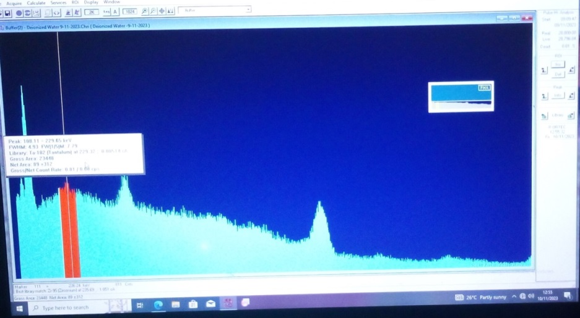
- Obtaining spectral data

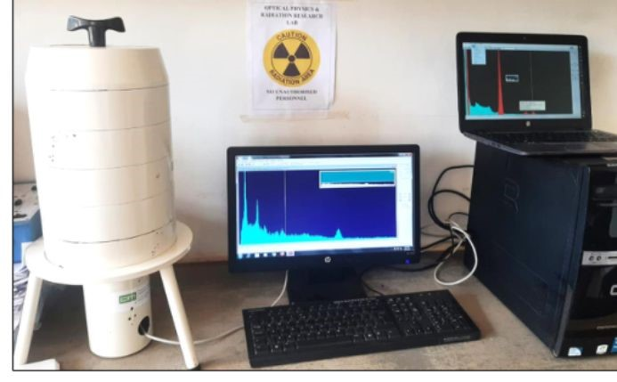
- Sodium Iodide Detector with its Accompanying Electronics At SEKU

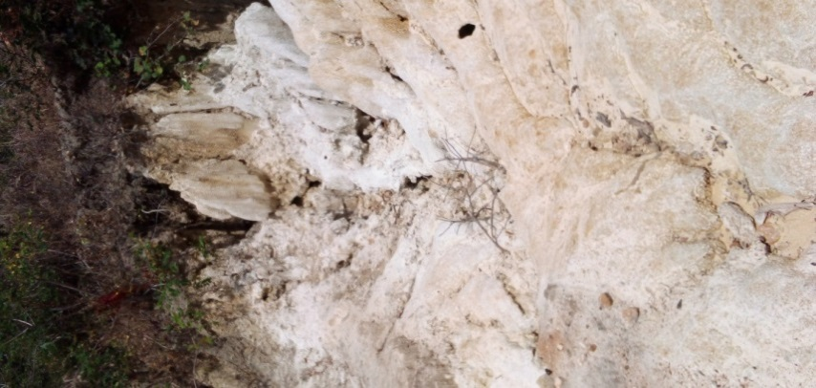

- Limestone rocks at Kiang’ombe hill

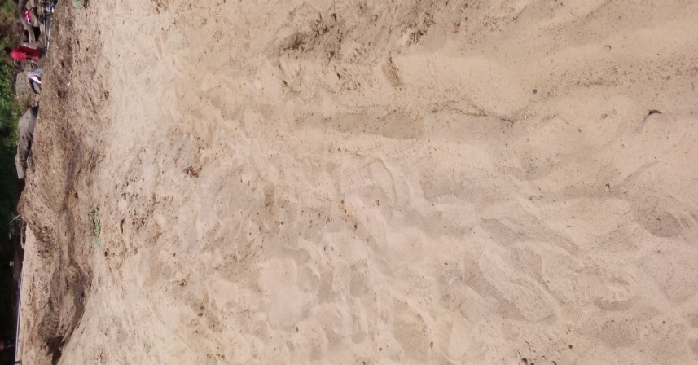

- Sand harvesting along River Thura

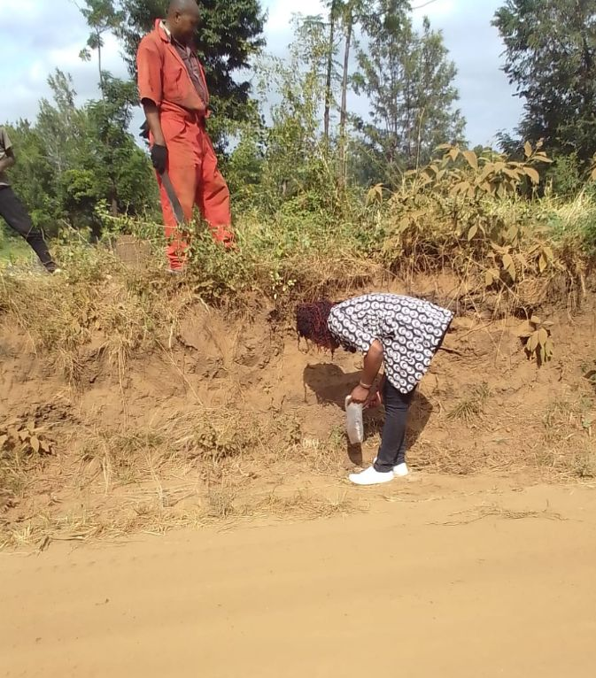

- Sample collection at Gitie

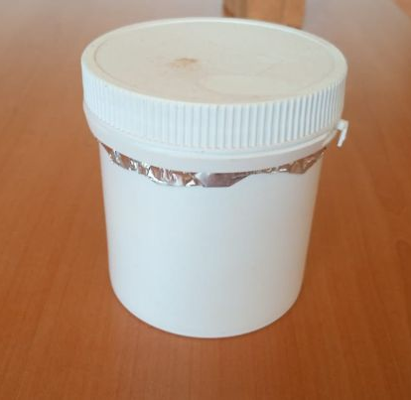
- Sample prepared at Tharaka University

APPENDIX II: INTRODUCTORY LETTER


APPENDIX III: ETHICS CLEARANCE


APPENDIX IV: RESEARCH PERMIT


