Ungodliness Or Dissidence? A Critical (Re)Valuation Of Religious Internet Memes

Timothy M. Kangori¹* Mukasa Mate² Jane Mugo¹ & Mary Karuri¹
¹Tharaka University, P.O. Box 193-60215, Marimanti, Kenya
²Chuka University, P.O. Box, 109-60400, Chuka, Kenya
*Corresponding Author: Timothy M. Kangori, Department of Humanities and Social Sciences, Tharaka University, Kenya

Abstract
Religious subjects are rarely taken head on in artistic or public discourses. For instance, seldom are holy scriptures or teachings openly questioned given the hallowed nature of religious matters. This, however, does not imply that religious institutions are devoid of ugly underbellies. As such, literary texts have always exposed religious hypocrisies, earmarked by norms that deviate from religious teachings, albeit with hushed undertones. Technological waves have resulted into expanded surfaces through which artistic oeuvres are mediated. This paper assesses modern artists’ appropriation of social media spaces that are birthed by technological advancements in handling this sensitive matter. As such, the study adopts a qualitative research design in analysing religion-faceted jocular popular art forms namely internet memes to determine whether they embody ungodliness, religious dissent or otherwise. Relief, Superiority and Incongruity Humour theories as well as Cultural Criticism couch the discussions. The study concludes that despite the outer veneer that paints religious jocular discourses as ungodly and a form of dissent, they are ideologically loaded and point at crucial power relation dynamics in religious institutions. This indicates that such discourses afford the general populace opportunity to engage the normatively controlled religious metanarratives freely.
Key Words: Cultural criticism, dissidence, humour theories, jocular, memes, ungodliness

---------------------------------------------------------------------------------------------------------------------------------------

Date of Submission: 10-08-2023 Date of Acceptance: 20-08-2023
---------------------------------------------------------------------------------------------------------------------------------------

- Introduction
Around the time of writing this paper, local and international media outlets were awash with news of a pastor in Malindi in Kilifi County in Kenya who allegedly prevailed on his congregation to fast to death so that they could meet Jesus in heaven. Many of his followers succumbed to the fast and their bodies were unearthed from shallow graves in Shakahola forest. Ironically, some of the naïve followers would sell their property; give it to the pastor before proceeding for deathly fast that they believed would lead them to heaven. Strange yet, the conniving pastor never fasted devotedly enough to earn him an early ticket to meet his creator. This is a classical example of indoctrination, an overblown ideological manipulation of the congregation.
This and other related incidences exposing religious sects for ideological indoctrination underscore pervasiveness of religious teachings that remain unquestioned due to the belief that they are infallible. While religious matters are held in sanctity by many, writers have not shied from dissecting this institution while highlighting, exposing and commenting about covert intrigues that circumvent religious institutions. In canonical poetry for instance, Okot P’Bitek in Song of Lawino (2013) uses Lawino to satirize some Christianity’s teachings and practices. Through her, he criticizes religious leaders for being drunk while ministering, moral decadence amongst other despicable and incongruous tendencies. He also pokes holes into Christian practices such as the Holy Communion, baptism, prayers and the creation story. While these satirizations come on the backdrop of cultural alienation, the subject matter in this poetry, the poet, nonetheless, raises pertinent concerns about Christianity for deeper contemplation. Generally, P’Bitek joins coterie of writers who have engaged with religious subjects though in varying shades and typically with satirical overtones. Similarly, through widened possible artistic surfaces such as WhatsApp and Facebook, memers have continued to engage with the usually hushed religious subjects offering new and thought-provoking insights towards the institution.
Storey (2009) suggests thematic areas that can be investigated in memes, which are popular culture texts. These are class, gender, ethnicity, race, region, disability and sexuality. The present study expands Storey’s thematic scope by assessing memers’ engagement with religion. Additionally, Laineste and Voolaid (2016) assert that through memes, people are able to comment about various topics and can use them to “comment on the problems and scandals they find relevant…as well as providing “an entry point, sometimes even the first exposure to topical “hot” and debated issues” (p.44). The present study assesses the memetic handling of religion, which is not only a ‘hot’ but also very sensitive matter that is normally hushed in private and public discourses. Thus, the study agrees with Iloh (2021) who argues that the meme genre provides an easy means for addressing sensitive and serious concerns.
Cultural Criticism and Humour theories are employed in analysing religion-reflecting internet memes. According to Sardar and Loon (1999), Cultural Criticism originates from Cultural Studies, a broad methodology which “is used to describe and study a whole range of practices” (p. 6). This approach can be applied in literary criticism as well as in other disciplines. Through this approach, cultural texts are analyzed on the background of their underlying contexts; historical, social, political or economic. It has foundations in the ideas of Richard Hoggart, Raymond Williams, Stuart Hall among others.
Richard Hoggart is believed to be the father of Cultural Studies following his seminal work, The Uses of Literacy published in 1957. In this work, he laid the foundations for British Cultural Studies by celebrating the culture of working class people through appreciating their popular culture. The major assumption in this work is that popular papers, magazines and various commercially driven mass communication outlets targeted the working class. Raymond Williams’ contribution to the theory is through his definition of the term culture in his book, The Long Revolution (1961). In this book, he fronts three definitions of culture, all of which ground Cultural Criticism as a theoretical approach. He first perceives culture as a state or process of human perfection with regard to certain complete or universal values. Therefore, an analysis of culture would involve “the discovery and description, in lives and works, of those values which can be seen to compose a timeless order or to have permanent reference to the universal human condition” (p. 57). . Finally, Hall (1980) traces the emergence of Cultural Studies in the mid 1950s. He regards culture as something that “is threaded through all social practices, and is the sum of their inter-relationship” (p.60). He goes on to define the theory of culture as “the study of relationships between elements in a whole way of life “p.60). A cultural analysis should be committed to examining relationship between such elements in order to understand any cultural material comprehensively.
The study benefits from cultural criticism’s proposition that all forms of cultural production, when analyzed, can reveal their cultural function through their shaping of our experience by being transmitters and transformers of ideologies. In this regard, cultural products are considered in light of their role in the circulation of power. This paper seeks to expose religious ideologies and power dynamics in Kenya’s memetic discourses. Thus, efforts are made to demonstrate that humorously figured religious matter can superficially be regarded as ungodly or a form of dissidence, determinations that veils critical ideologies and power dynamics in such discourses.
The study also relies on Incongruity theory of humour, which is attributable to Cicero, Kant, Schopenhauer and Kierkegaard (Monroe, 1967; Morreall, 1987a). The theory holds that human beings perceive the world to be governed by rational chains of causes and justification. Therefore, when situations fail to conform to rational conceptualization of the world, incongruity occurs. The theory explains that humour occurs when two conflicting ideas that violate our expectations are introduced. The conflicting ideas go against the expected norm, introduce surprises and unconventional matter hence making people laugh. Carrell (2008) defines Incongruity theory as one that is concerned with the stimulus where the audience is left to “identify, perceive and resolve the incongruity already present in a text” (p. 312). Thus, Incongruity humour occurs when something ludicrous, exaggerated or absurd confront people.

- Dissidence or Ungodliness?
Religious dissidence in this study’s context refers to insurgent, acerbic and cynical attitude towards a religion, its teachings or followers. Conversely, memetic ungodliness refers to flippant attitude towards spiritual matters. Flippancy refers to disdain and light-hearted treatment and attitude towards religious issues. For instance, the satirical tone employed by P’Bitek in criticising Christianity’s malpractices and teachings in Song of Lawino superficially paints Lawino, his poetic mouthpiece, as Christianity’s rebel. Further, Lawino’s attack on the Christian institutions borders on ungodliness. However, these surmises cloak other critical insights that can be gleaned from the persona’s diatribe towards Christianity. Similarly, while the items discussed in this section outwardly insinuate religious dissidence and ungodliness, deeper scrutiny expose redeeming fronts.

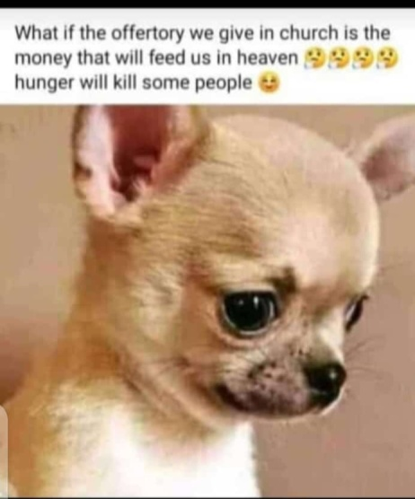
Figure 1 Figure 2
Figures 1 and 2: Memetic Views on Church Offering

Figure 2 dramatizes Judgement Day where a character asks for a refund of his entire offerings after being told by an angel that his name is not in the book of life. The two memes bear the image of a puppy and dog respectively to accentuate weird but pertinent viewpoints about church offering.
The meme’s caption in figure 1 elicits Incongruity humour in driving its inherent questioning agenda. A punch line occurs when the memer wonders what those who do not make offering will eat in heaven if it turns out that they would be fed using offerings somebody gave while on earth. To discern the punch line, one must be well versed in biblical teachings to know that offerings will not be used to feed people in heaven. Though farfetched and biblically illogical, such an item can delude a gullible congregation or church members by inculcating fear of hyperbolically untold heavenly starvation upon failure to comply.
Figure 2 exposes underlying intentions of people when they give church offering. The meme dramatizes the Judgment Day through an Angel and an adamant human being. This item is loaded with dramatic irony when the human being demands a refund of all offerings after missing from the book of life. Dramatization of the judgment day by bringing offerings in the plot exposes some Christians’ naive thinking that offerings may earn them entry in heaven. Dramatic Incongruity is achieved when the persona asks for offerings’ refund, a request that is impractical in Christian teachings and one that borders on folly as reflected in the surprised reaction of the dog and emoticons of laughter evoked from the daft request.
Different shades of materialism in churches are exposed in the two items. The memetic persona in figure 1 threatens poor givers with starvation in heaven in order to compel them to give generously. This surmise traces the origin of the item to spiritual leaders who would wish to see higher church offerings. Conversely, the next item exposes materialistic church members who may assume that offerings would earn then direct ticket to heaven. Other related memetic oeuvres have exposed dishonesty in the handling of church offerings. For instance, memes have featured shocked members when a pastor announces an offering that is lower than the amount they alone gave. The difference between the announced and the expected amount definitely points at possible pilferage of the offertory.
The propensity of spiritual leaders to enrich themselves while impoverishing the congregation has been dramatized in Mulwa’s Redemption (1990) through Archbishop Muthemba who embezzles church funds for self-enrichment and indiscriminate acquisition of his congregants’ land. When Manela, a new pastor is posted in the region, he is worried that the church’s records would expose embezzlement of church’s funds. Mulwa’s play therefore authenticates the far-fetched and unimaginable meming of pilferage of church offerings as well as materialism in churches. The item paints the church negatively by exposing entrenched evil in churches. This undermines its effectiveness to serve as a moral beacon. However, on the positive flipside, the meme creates necessary awareness in churches and other religious bodies that would compel the leadership to enlist individuals of integrity to handle churches finances.
The two memes above utilize Advice Animals which according to Dynel (2016) entails the use of animals or even humans accompanied by a captioned text to represent some character traits or archetype. The use of animal images of a puppy and a dog is to complement the already complete captions which have already achieved the threshold of humour and to consolidate the message. This aspect resonates with Dynel’s observation that when creative captions achieve totality of humour, pictures come to complete the meme’s visual-and verbal aesthetics. In figure 1, the puppy’s facial disposition endows the meme with the required introspective emotional colouring when the scenario of going without food in heaven is attributed to not having been giving offerings in church. Similarly, in figure 2, the punch line has already been achieved in the caption. The dog’s facial captures the surprised reaction of a third party individual who is taken aback by the audacity and stupidity of asking for a refund of offering. This way, the dog’s astounded appearance is an archetypal metaphor for shocked stance at strange human behaviour and mannerisms. The use of this archetypal dog’s image is a recurrent satirical vehicle for ridiculing such and other related human follies.
Expectedly, any form of religion is supposed to be practiced and regarded with utmost respect by its practitioners or outsiders. The following items expose select flippant attitude of memers towards religion and more specifically, on Christianity.

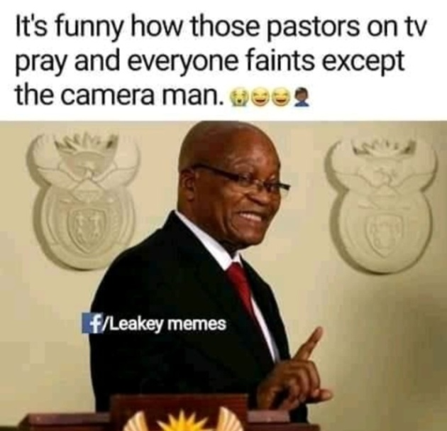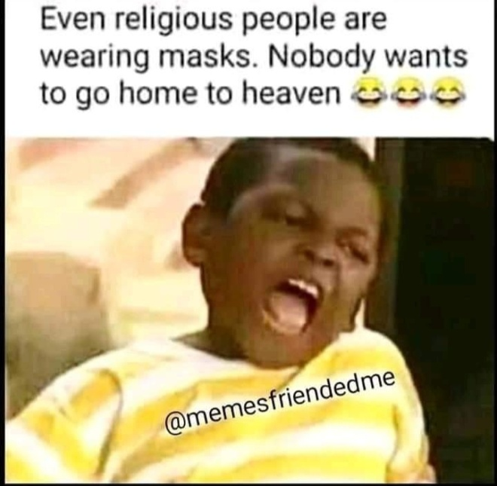
Figure 3 Figure 4
Figures 3 and 4: Criticism on Christian Practices

As stated in this paper’s introduction, rogue preachers can hoodwink gullible believers into taking life-threatening actons like fasting to death. In figure 3, the memer takes a swipe at pastors miracle theatrics in Television where everyone faints when they pray apart from the camera man. This aspect consolidates incongruity humour aesthetics in the meme since it would be expected that every one in the congregation would not be spared by the powerful prayers. The meme is contextually informed by prevalent cases of preachers who beguile faithfuls by claiming to have the ability to perform miracles and deliver them from satanic shackles. Clearly, the memer expresses reservations towards genuity of such prayers sessions through presenting the incongruous turn of events where some individuals in the congregation are impervious to those prayers. This exposure definitely borders on dissidence and ungodliness since spritual matters are not supposed to be questioned by mortal man. However, the meme genre presents an opportunity to engage such a sensitive matter through disarming humour which desensitivises the matter.
Figure 4 is informed by Covid-19 pandemic which struck the entire world in the year 2020 and 2021. To mitigate the pandemic, several safety measures were adopted among them wearing masks. In the meme, the speaker derides religious people for wearing masks out of fear of contracting the killer virus. To the memer, religious people should not wear masks but should instead ignore the measure because even if they die, the would go to heaven. This meme covertly questions christianity teachings about heaven. The memer suggests that christians are not sure about heaven hence the reason why they wear masks to avoid dying. The meme could also suggest that religious people are not ready to die because they are sinful and their ticket in heaven is not assured. Like figure 3 that employs the image of Jacob Zuma, a former president of South Africa, the use of the popular figure of Osita Iheme, a Nigerian film actor in figure 4 is for rhetoric and popular persuasiveness. When sarcastic and satirical expressions and undertones that undermine religion and religious practices emanate from celebrity figures; their dissident and ungodly nature is both veiled and amplified.
The following memes further present flippant attitude towards biblical scriptures.


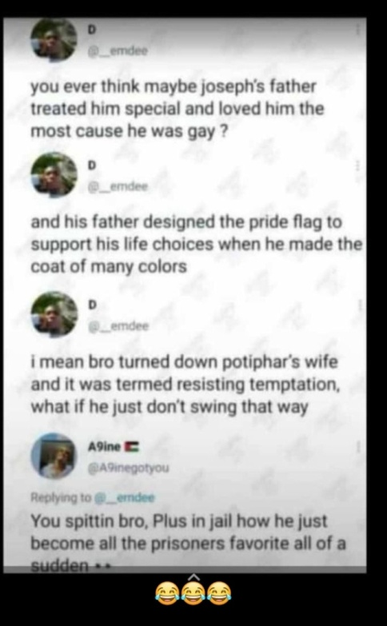
Figure 5 Figure 6
Figures 5 and 6: Criticism on and overturning Scriptural Meanings

The speaker in figure 5 echoes Lawino’s cynicism towards religious by criticizing and questioning a serious Christianity issue just like Lawino who bases her criticism on apparent contradictions or loopholes in the bible. On the other hand, figure 6 dialogically employs colloquial English to drive gay agenda through a spurious reading of the bible.
The speaker in figure 5 cannot understand why God killed his son for atonement of humanity’s sins instead of killing Satan. The reasoning behind the item is that if Satan would have been killed, there would have been no sin in the first place. Ironically, this did not happen hence the meme that attempts to deal with the illogicality. Just like in figures 2 and 3, the meme employs Animal Advice technique where the image of a man in deep thoughts accentuates the questioning sentiments raised in the caption. Incongruity humour is elicited in the caption, which espouses an apparent biblical illogicality. The man’s image represents the memetic persona and by extension, an archetypal metaphor for other such individuals with flippant stand points on biblical teachings. The meme employs graphological deviation, which entails deviating from norms governing text’s appearance on paper with respect to capitalization rules, font size, bold and italicization of letters and words. In the caption, the expression ‘OUR SINS’ is foregrounded through capitalization and large font, an feature that makes the expression to stand out from the rest of the caption. This technique enhances the caption’s textual and visual aestheticism and isolates mankind’s sins for the overarching incongruity in the item.
While employment of satire and humour aesthetics in questioning biblical teachings may not be agreeable with Christians, the style, according to Wimsatt (1969), is deployed in issues deemed dangerous and offensive. While parodying any religion in fiction and popular art forms may be offensive to individuals whose faith is targeted, the audience is nonetheless provided with ephemeral avenues for accessing suppressed religious facts and ventilating their suppressed questioning stances towards their faith. Thus, as Barber (1987) argues that popular arts provide access to undeniable social facts, the fact that mainstream fiction has also handled private and seclusionist subjects such as inherent ironies in religious beliefs and practices underscores artistic truthfulness in popular art forms such as memes in exposing religious flippancies.
The speakers in figure 6 strike a conversation to build the argument that Joseph was gay through what this study refers to as memetic heteroglossia. According to Bakhtin (1981) heteroglossia occurs when meaning in a text or speech is based on social contexts which can still attract further opposition hence providing alternative meanings. The varying social contexts insinuate intertextuality richness of such texts. For instance, the memetic exchange above involves two individuals who overtly allude to the biblical story of Joseph’s betrayal by his brothers, his imprisonment in Egypt and altercation with Potiphar’s wife, before arriving at a gay surmise. The speakers’ arguments are based on biblical facts that Joseph turned down Potiphar’s wife sexual offer. The inference made from this biblical fact is that he was gay. To further substantiate the claim, one speaker cites further biblical evidence like that Joseph was loved by his father more than his brothers and in prison; he turned out to be the prisoners’ favourite.
This item exposes heteroglossic stances from several fronts. The speakers most likely exploit their gay orientations to conclude that Joseph was gay. Secondly, the first speaker initiates the gay allegation claims with a speculative statement, which begins with the words “you ever think maybe…” and ends the statement with a question mark. These expressions disclose the speaker’s uncertainty thus insinuating refutability of the interpretation. The heteroglossic nature of the meme is highlighted by the first speaker’s readiness to dialogically engage with other individuals with similar or contrary opinions. The second speaker agrees with the first speaker’s interpretation as seen in his supportive input to the argument. It is noteworthy that heteroglossic texts go beyond the speakers to include listeners who may have different opinions towards a controversial matter. According to Bakhtin (1981) harmonious or disharmonious voices resulting from differing interpretation of texts create a worldwide cultural dialogue.
When the item is assessed from a staunch Christian’s context, it may appear sacrilegious because the word of God as enunciated in the bible is supposed to be “yes and amen.” The memers behind such items could be dismissed for shallowly reading the bible thus the isolated, narrow and skewed interpretation of contradictory events or sections of the bible. As a result of this shallow reading of the bible and based on their queer sexual orientations, the two voices misinterpret Joseph’s story to arrive at the conclusion that he was gay. Expectedly, the cordial relations between Joseph and his father and other men in prison would be interpreted as such by gay readers. This gay interpretation however does not explain scriptural instances not referred to in the item where Joseph is said to have been so hated by his brothers, to a point of planning to kill him. Despite instant condemnations figure 6 would attract from Christianity and heterosexual populations, it propagates a heteroglossic queer reading of the bible attributable to queer sexual backgrounds of the speakers. However, the meme’s audience would test the truthfulness or otherwise of this interpretation based on their sexual orientation and comprehension of the bible.

- Power Dynamics and Ideologies in Religious Memes
Figure 1 ideologically perpetuates the importance of church offering. This is achieved by challenging those who do not make offering or give sparingly suggesting that such individuals would perish from hunger in heaven. This kind of reasoning is meant to act as a form of activism in religious groups. The caption’s syntactic segment “What if” implies mere speculation in the rest of the satirical statement and is meant to whip members to give generously and bountifully using the scare of eternal hunger after death if they do not comply. This argument resonates with Wa Thiong’o’s (1981) observation that religion can be used as means for political and economic power consolidation, rationalizing repressive practices and coercing people to conformity by warning of eternal punishment. In this case, the meme ironically intends to consolidate earthly possessions by spiritual leaders by warning of a famished eschatological eternal life in the statement, “hunger will kill some people.”
Further, the memes in figures 5 raises pertinent questions that most people would never have dared ask about the bible. Seeking clarifications on the word of God is normally frowned upon for such would be viewed as religious dissidence or atheism. The joke genre whose gravity and seriousness is fore-disarmed by laughter and humour happens to be the most effectual tool for engaging with sensitive matters like religion. While majority of Christians would disapprove such jokes, the joke genre provides a platform upon which biblical content can be criticized outside theological spheres and by all sorts of people. A layman is afforded opportunity to direct criticism towards ambiguous or contradictory scriptures or teachings hence inviting an opportunity for open debate about the same.
While protest and rebellion against some Christian teachings, scriptures and mannerisms can be gleaned from figures 3, 4 and 5, fundamental spiritual power negotiations are taking place, not for the sake of usurping the supremacy of the word of God as it may superficially be construed but to seek clarifications on contentious areas in the bible. This supposition underscores the fact that power relations and negotiations are everywhere as Foucault observes including in religious matters. Figure 3 (re) negotiates spiritual power consolidation in the pastor by questioning the camera man’s resistance to prayers. This questioning forces such pastors to rethink their miracle propensities and perhaps rectify and seal obvious loopholes in their spiritual operations.
Figure 4 seeks to perpetuate and sanction wicked tendencies by insinuating that even religious people fear dying because their entry in heaven is not assured given possible sinful lives. While this exposes faithful negatively, it constructively triggers thoughtful reflection and meditation about scriptural teachings especially those about life after death. Generally, figures 3, 4 and 5 attest to the fact that subscribers to any faith, given acceptable channels of expressions, can constructively engage with its doctrines and mannerisms of its practitioners not for revolutionary agenda, but for the purpose of acquiring deeper insights into spiritual matters or righting deviant or incompatible religious practices.
Sexual orientation, relations and negotiation dynamics percolate item 6. Overt biblical allusion is used to make a strong argument in support of homosexuality which Mate (2017) considers as representing sexual minorities in the society. The rationale behind using this technique is its persuasiveness when such negotiations are anchored on a meta-narrative text. Consequently, the memer is able to advocate for the gay agenda by making incongruous or even dubious interpretations of the scriptures. Connell (2000) acknowledges that homosexuality is silenced in public and work places as well as in the church while heterosexuality is voiced. The choice of memes to counter such silencing finds backing in Odhiambo’s (2003) attribution of popular fiction (or popular art forms in this study’s context) with capturing and dissemination of everyday practices which may receive suppression from dominant ideologies.
Inarguably, this item presents a heteroglossic argument, which openly vouchsafes for homosexuality through lopsided interpretation of the bible. Other than exhibiting religious dissidence and ungodliness, the meme’s speakers seek to construct and advocate for unnatural sexual orientations. The traction of this religious and culturally deviant sexual orientation argument is based on biblical scriptures, which the speaker uses to sanction and convince an unsuspecting audience into queer practice. Commenting on similar biblical invocations that seem to sanction queer expressions, Ombagi (2019) argues that such stratagems powerfully provide opposing narratives that intertwine queer practice with opposition to the practice. The meme exposes concerted effort by homosexuals or their sympathizers to resist homosexuality suppressions by taking the battle right at Christianity’s doorstep through the bible. This is enhanced through the meme’s dialogic structure, an effectual negotiating strategy in driving the gay agenda home.

- Conclusion
Religious-reflecting internet memes may superficially appear ungodly and dissident. This paper has not negated this reality. However, the analysis has established redeeming fronts in such internet memes. As such, the study has established critical religious power relation and negotiation dynamics in jocular discourses. When non-Christians or non-believers raise jocular flippant religious stances, intra-religious power relations and spiritual power struggle dynamics would be read from such items. Such dynamics would be pointers at society’s egalitarianism amidst an eclectically religious nation. In addition, liberty to constructively criticize and comment on others’ spiritual orientation would bolster cohesion, integration and tolerance from the religious front. Overturned scriptural meanings as evidenced in figure 6 affirms practices of using the bible and other religious texts by unscrupulous individuals for egoistic purposes. In this meme for instance, the speakers champion queer agenda through a lopsided interpretation of the bible.

References
- Bakhtin, M. M. (1981). The Dialogic Imagination. University Of Texas.
- Barber, K. (1987). Popular Arts In Africa. The African Studies Review, Vol. 3, 1-78.
- Carrell, A. (2008).Historical Views Of Humor. In V. Raskin (Ed.), The Primer Of Humor Research (Pp.303–332).Mouton De Gruyter.
- Connell, R.W. (2000). The Men And The Boys. Polity Press
- Dynel, M. (2016). “I Has Seen Image Macros!” Advice Animal Memes As Visual-Verbal Jokes. International Journal Of Communication, Vol. 10, 660-688.
- Hall, S. (1980). Cultural Studies: Two Paradigms. Media, Culture And Society. 2, 57-72
- Hoggart, R. (1957). The Uses Of Literacy. Chatto & Windus
- Iloh, C. (2021). Do It For The Culture: The Case For Memes In Qualitative Research. International Journal Of Qualitative Methods, Vol 20, 1-10.
- Laineste, L. & Voolaid, P. (2016).Laughing Across Borders: Intertextuality Of Internet Memes. European Journal Of Humor Research, 4 (4).26-49.
- Mate, A.M. (2017). Interrogating Masculinities In Selected Kenyan Popular Fiction. Unpublished Phd Thesis. University Of South Africa.
- Monroe, D. H. (1967). Humor. In P. Edwards (Ed.), Encyclopedia Of Philosophy: Macmillan.
- Morreall, J. (Ed.). (1987a).The Philosophy Of Laughter And Humor. State University Of New York Press.
- Mulwa, D. (1990). Redemption. Longman
- Odhiambo, T. (2003). Specificities: Troubled Love And Marriage As Work In Kenyan Popular Fiction, Social Identities, 9(3), 423-436. Doi: 10.1080/1350463032000130018
- Ombagi, E. (2019). Becoming Queer, Being African: Re-Thinking An African Queer Epistemological Framework. Unpublished Phd Thesis. University Of Witwatersrand
- P’Bitek, O. (2013). Song Of Lawino And Song Of Ocol. EAEP.
- Sardar, Z. & Loon, B.V. (1999). Introducing Cultural Studies. Icon Books.
- Storey, J. (2009).Cultural Theory And Popular Culture: An Introduction (5th Ed.). Pearson-Longman.
- Wa Thiong’o, N. (1981). Writers In Politics. East African Educational Publishers.
- Williams, R. (1961). The Long Revolutions. Chatto & Windus.
- Wimsatt, W.K. (1969). The Idea Of Comedy-Essays In Prose And Verse Ben Johnson To George Meredith. Prentice Hall

